Takatuf Sprint 1 Implementation and Testing Report
This report documents the implemented Sprint 1 Android interface. The main recruitment journey was demonstrated with separate owner and student accounts. Date-boundary failures and an event-linked expiry inconsistency remain unresolved; backend verification is deferred.

UI screenshots Account access
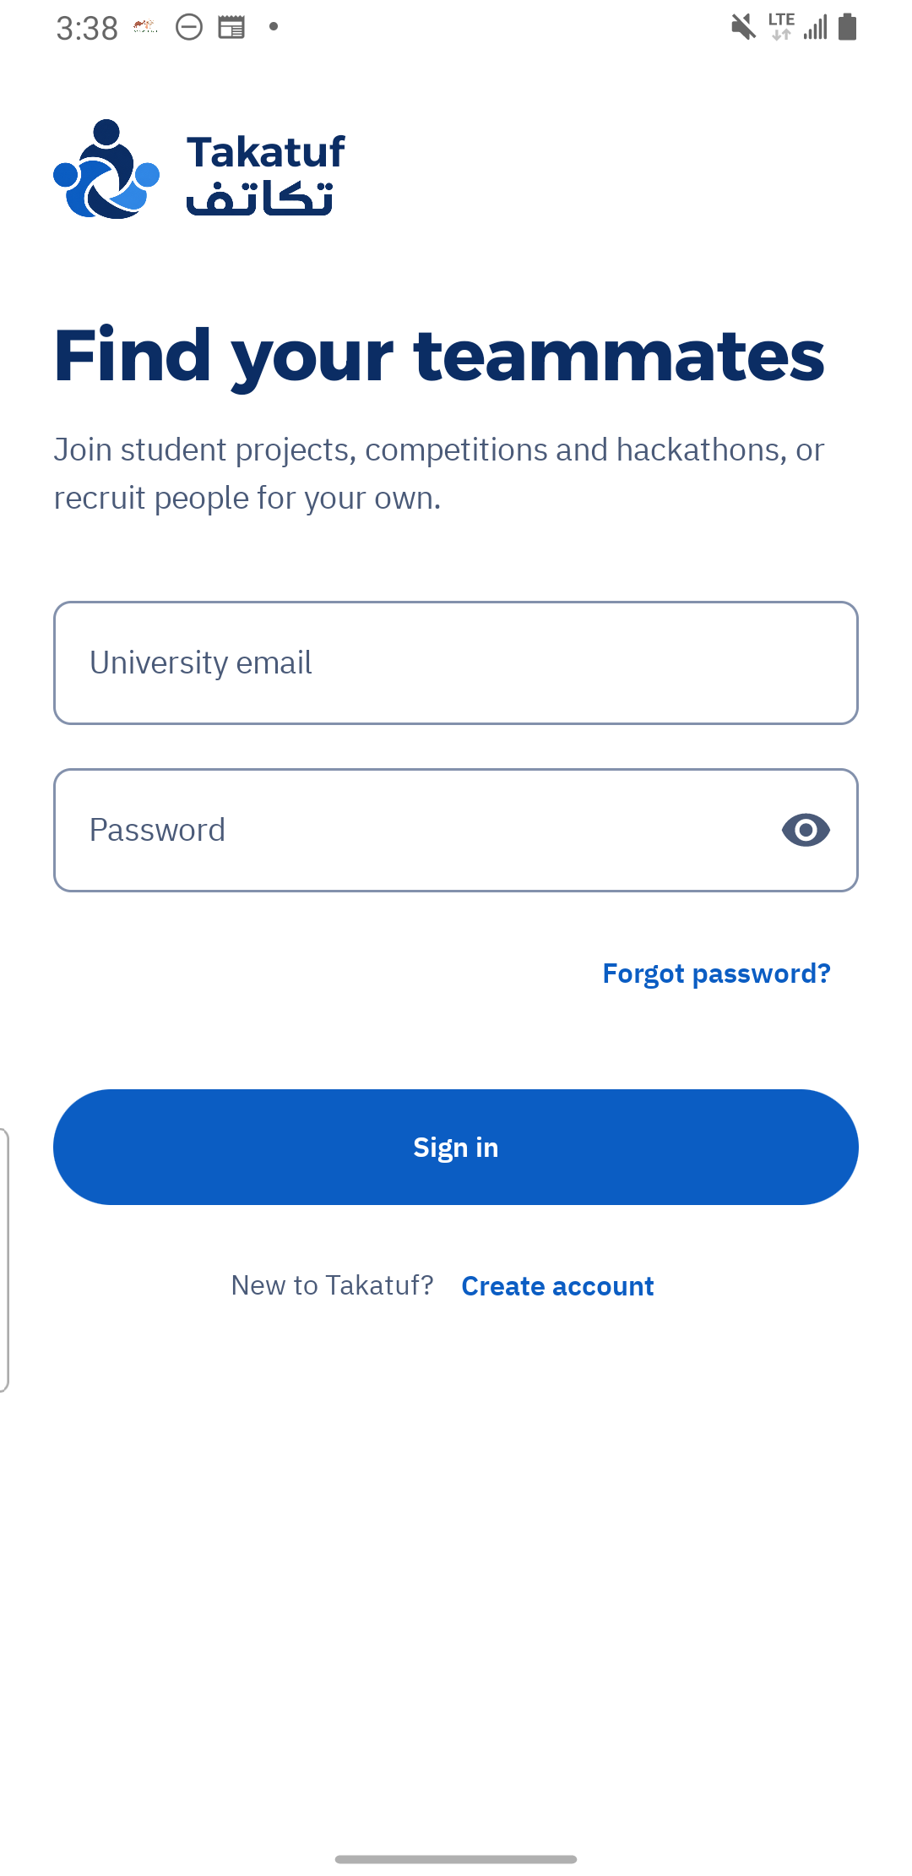  Figure 1. Login offers account creation and password recovery.  US01 / FR01 | Archive C1 | 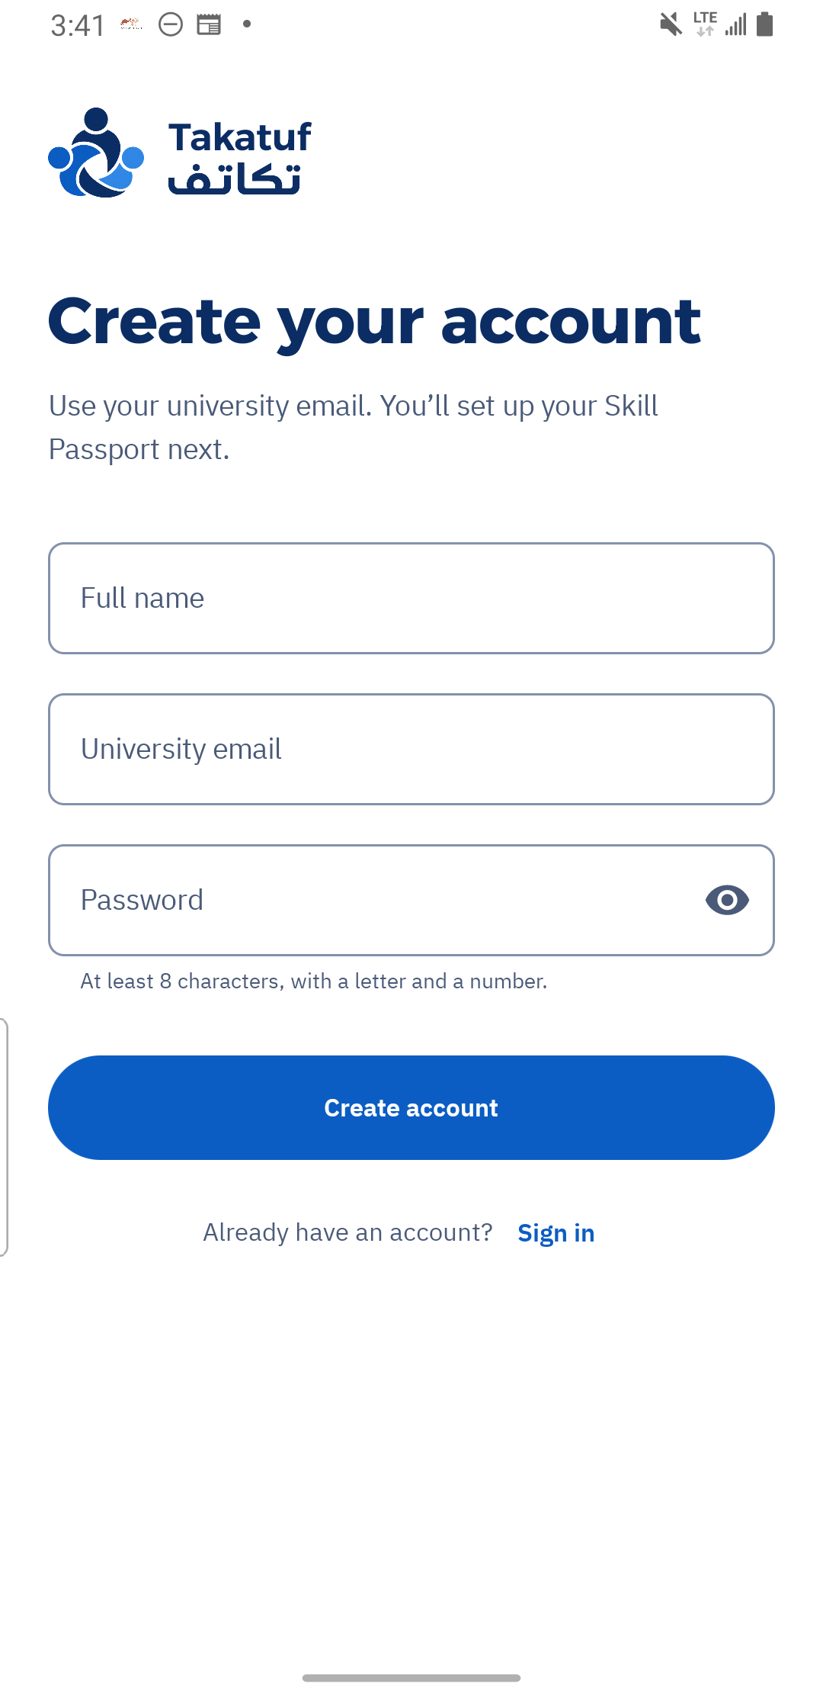  Figure 2. Account creation collects a student name, university email and password.  US01 / FR01 | Archive C4

UI screenshots Recovery and Passport editing
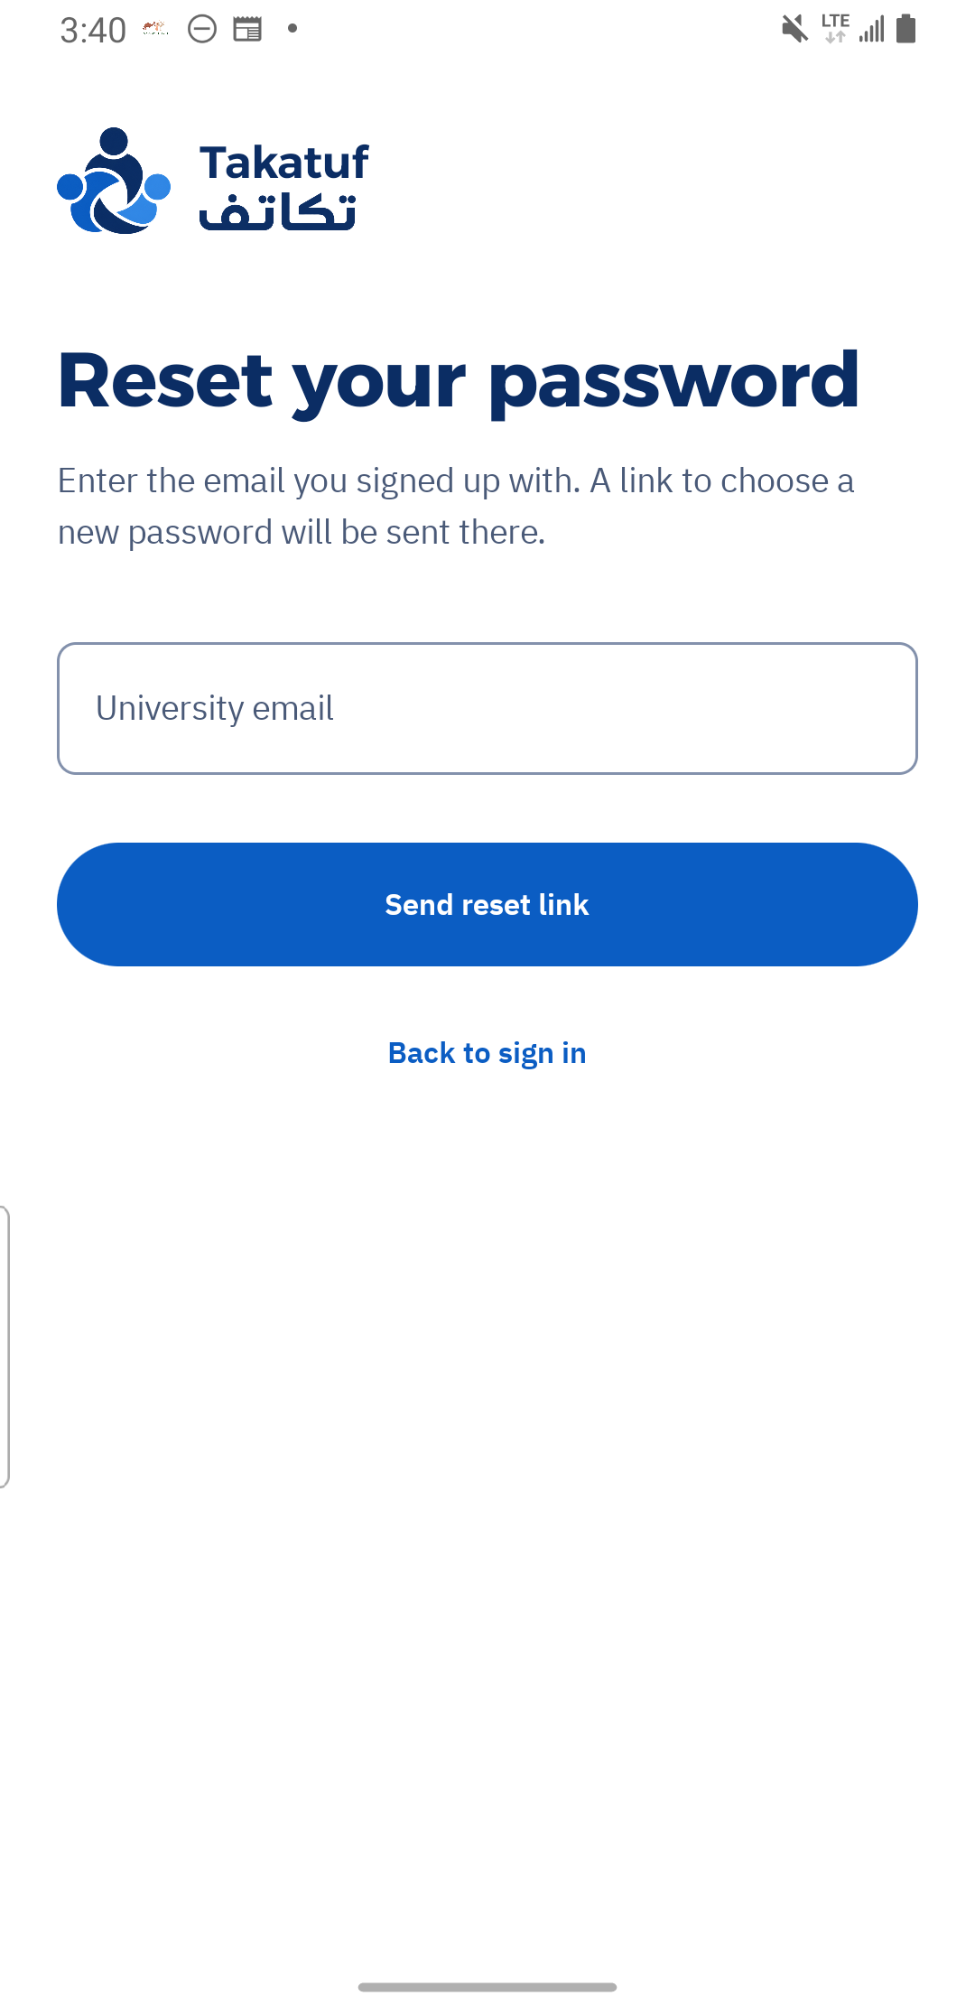  Figure 3. Password recovery request form. Reset completion was not demonstrated.  US01 / FR01 | Archive C3 | 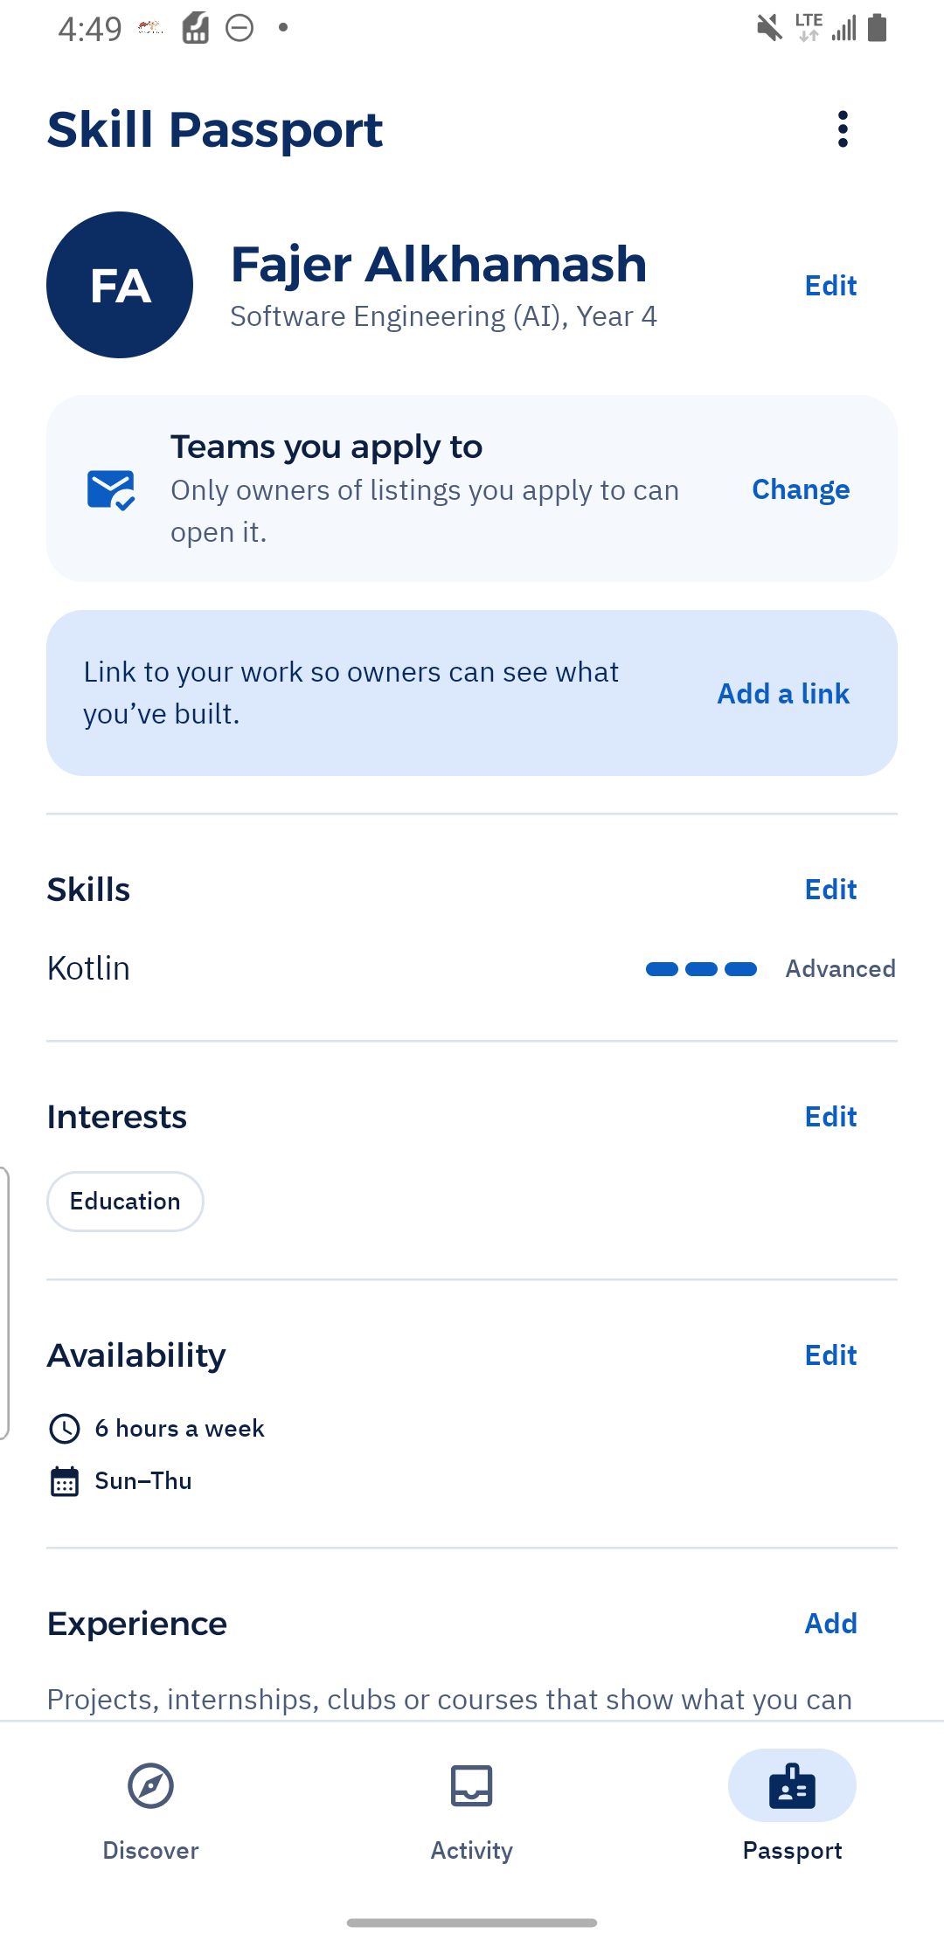  Figure 4. Saved Passport edits show Advanced Kotlin and Education interest.  US02 / FR02 | Archive C59

UI screenshots Passport information and privacy
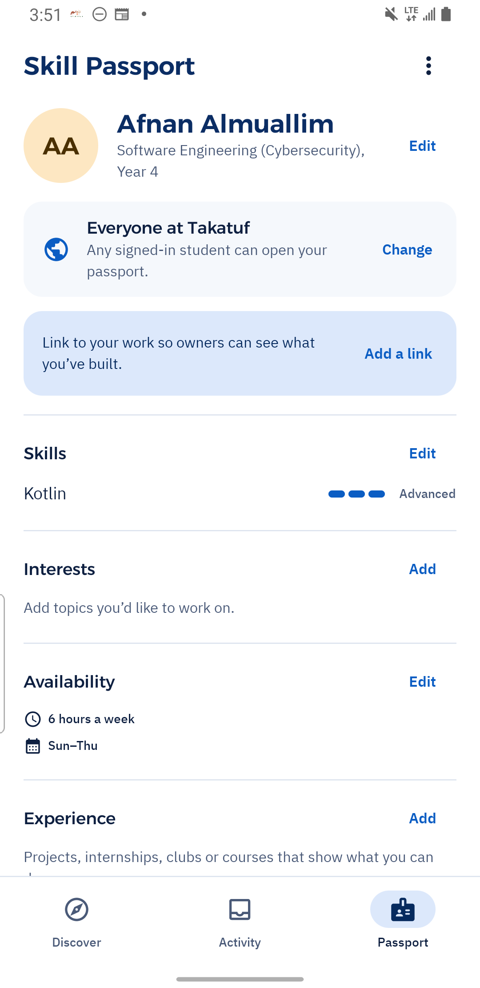  Figure 5. Afnan's saved Skill Passport shows skill and availability information.  US02/FR02–FR03 | Archive C11 | 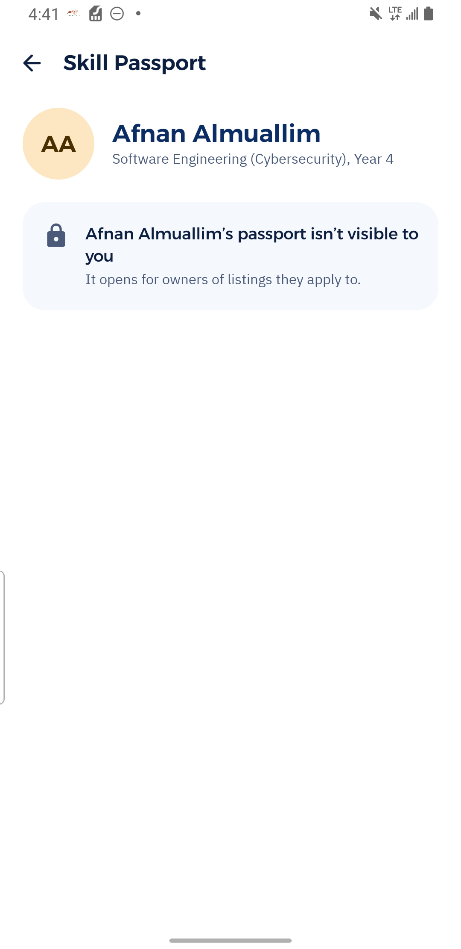  Figure 6. The unrelated student sees restricted Passport content under Teams you apply to.  US02 / FR03 | Archive C48

UI screenshots Role customization and project publication
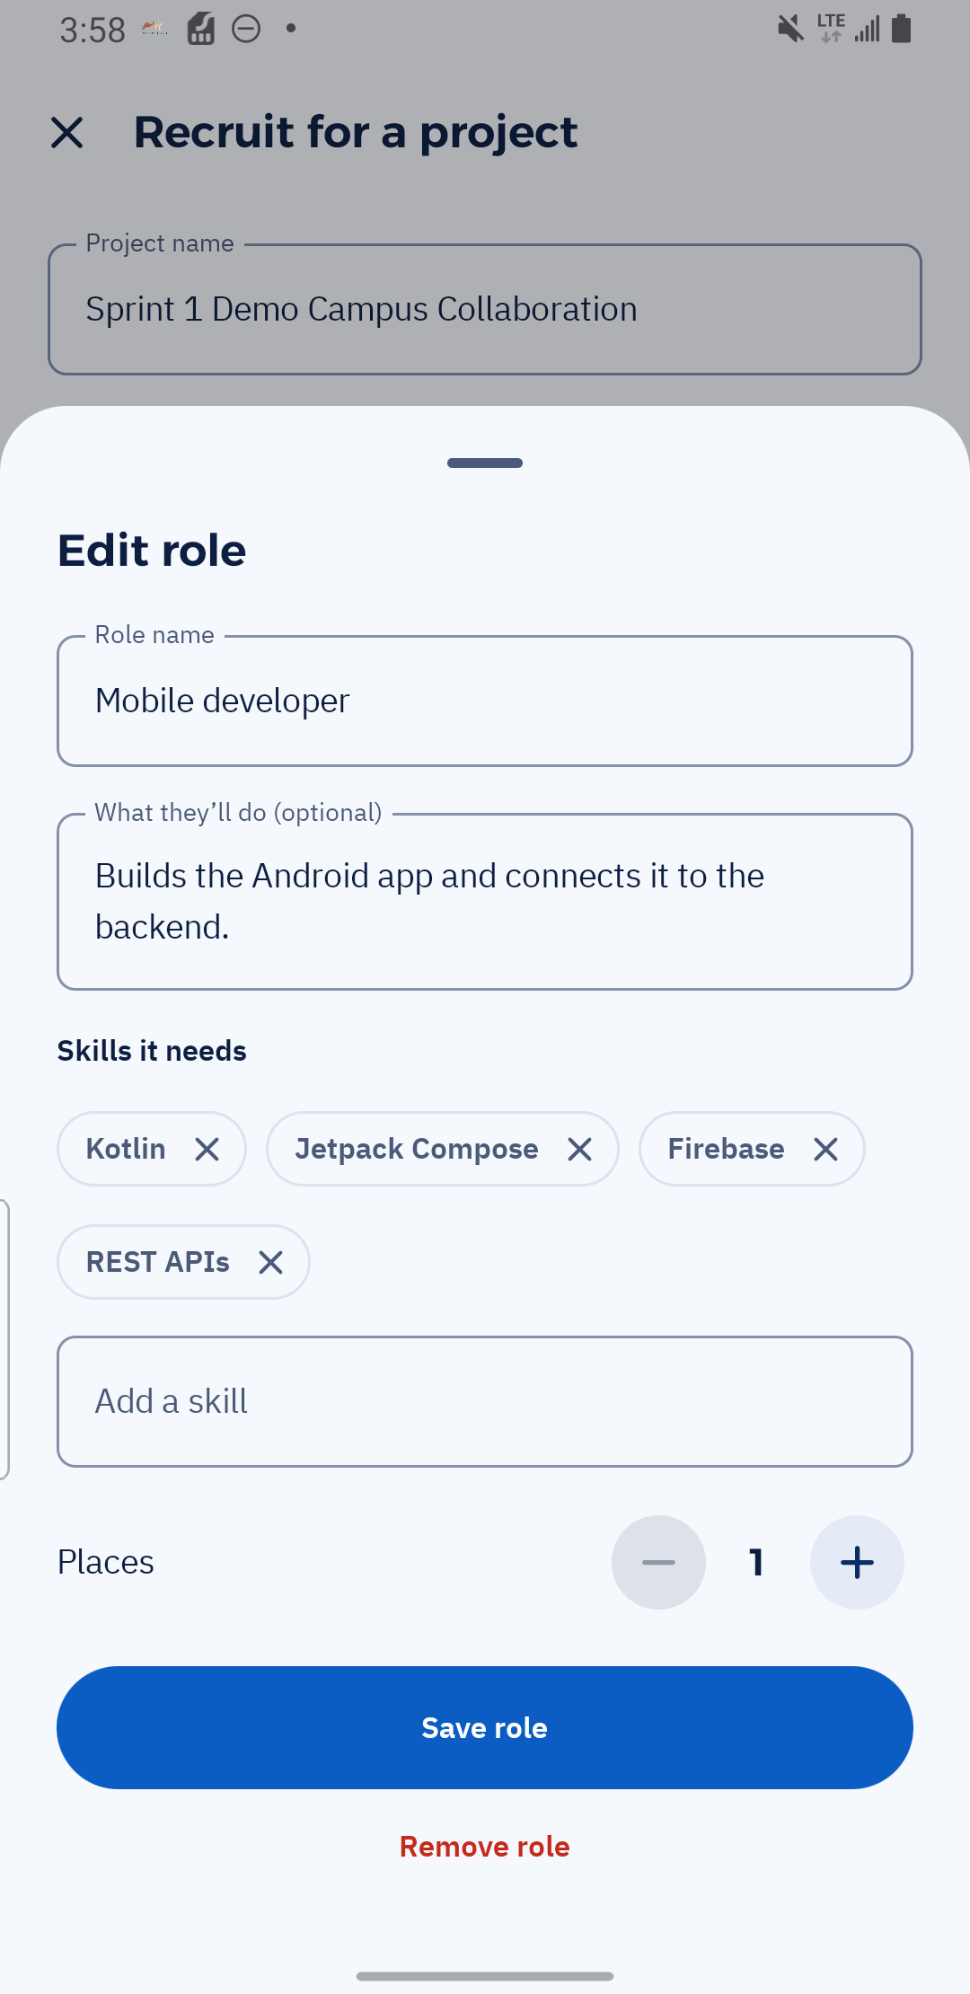  Figure 7. Mobile developer template allows skills and vacancy customization.  US03/FR08 | Archive C19 | 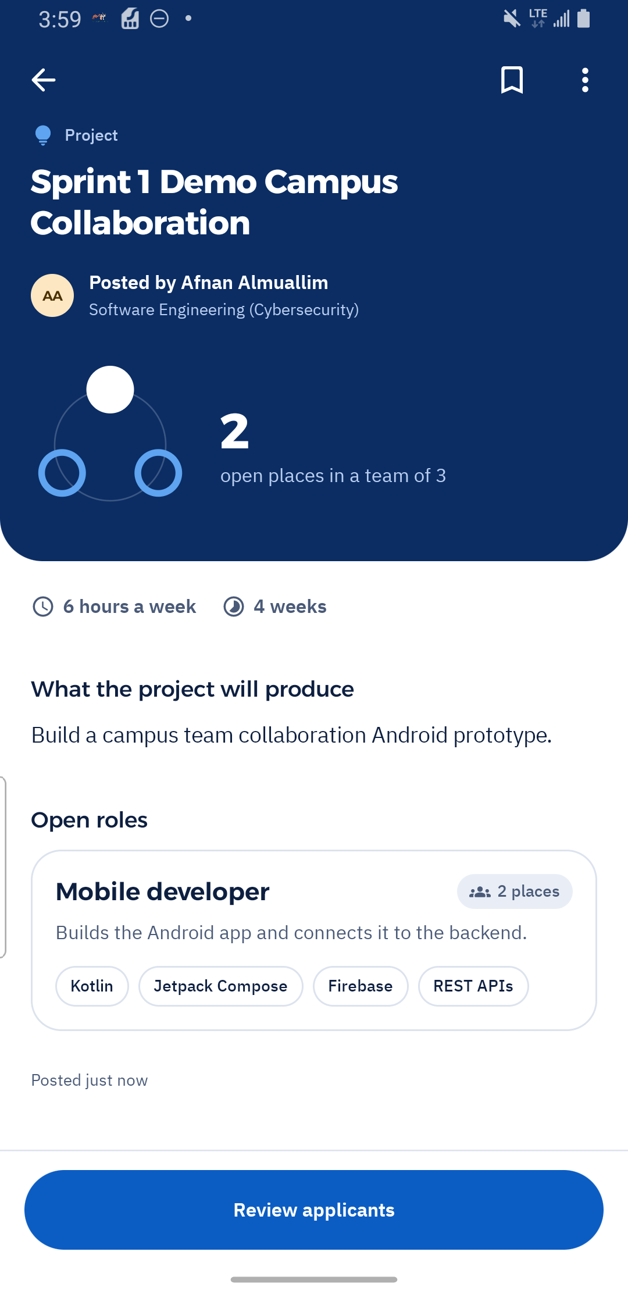  Figure 8. Published project shows outcome, commitment and two open places.  US03/FR04 | Archive C21

UI screenshots Competition and Hackathon details
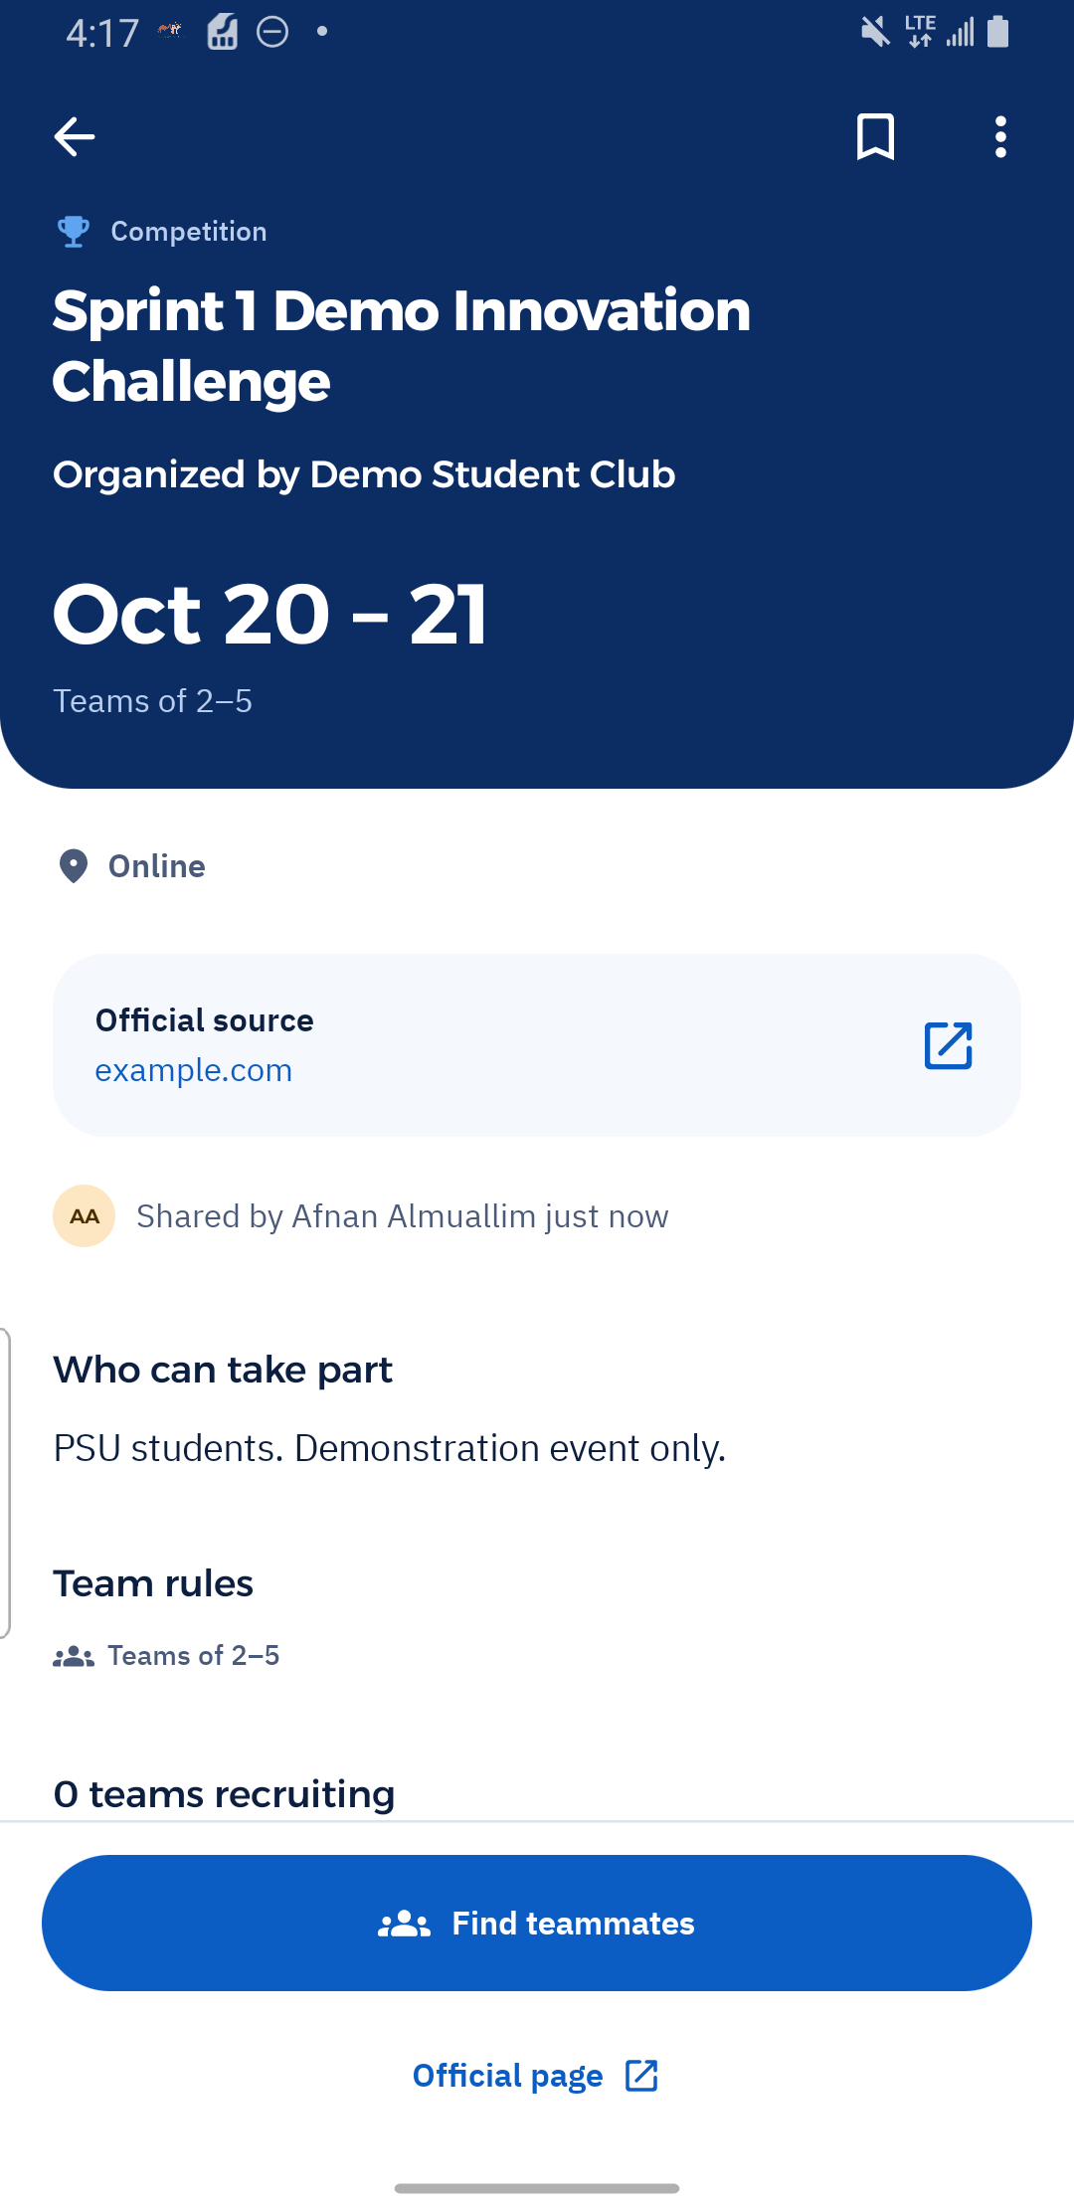  Figure 9. Published Competition distinguishes student publisher from event organizer.  US04/FR05 | Archive C29 | 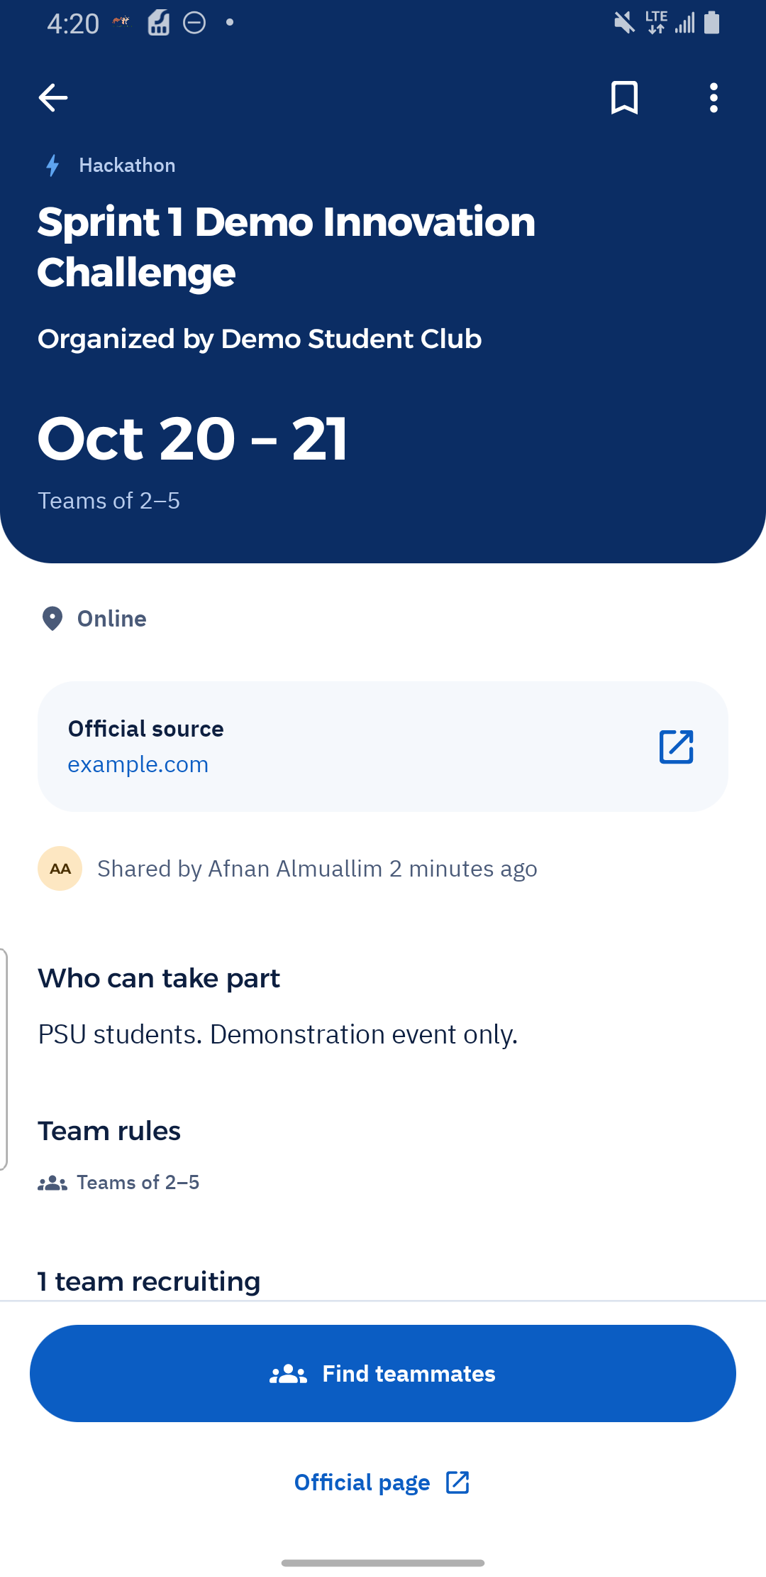  Figure 10. The same event is saved as a Hackathon with organizer, dates and source.  US04/FR05 | Archive C35

UI screenshots Event linked recruitment
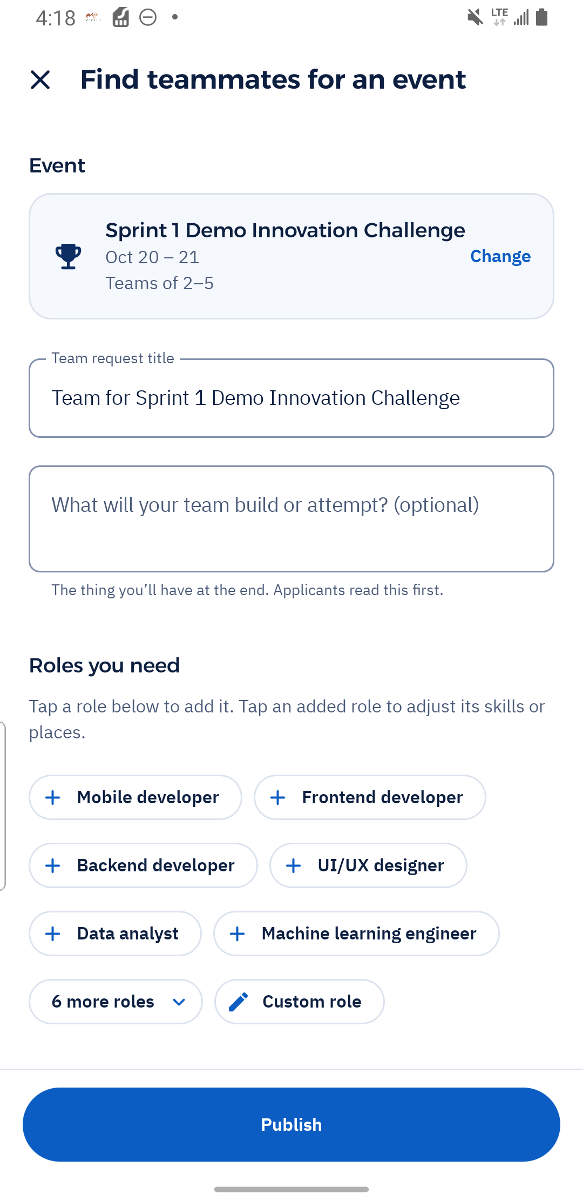  Figure 11. Team request creation preselects the published event and its rules.  US05/FR06 | Archive C30 | 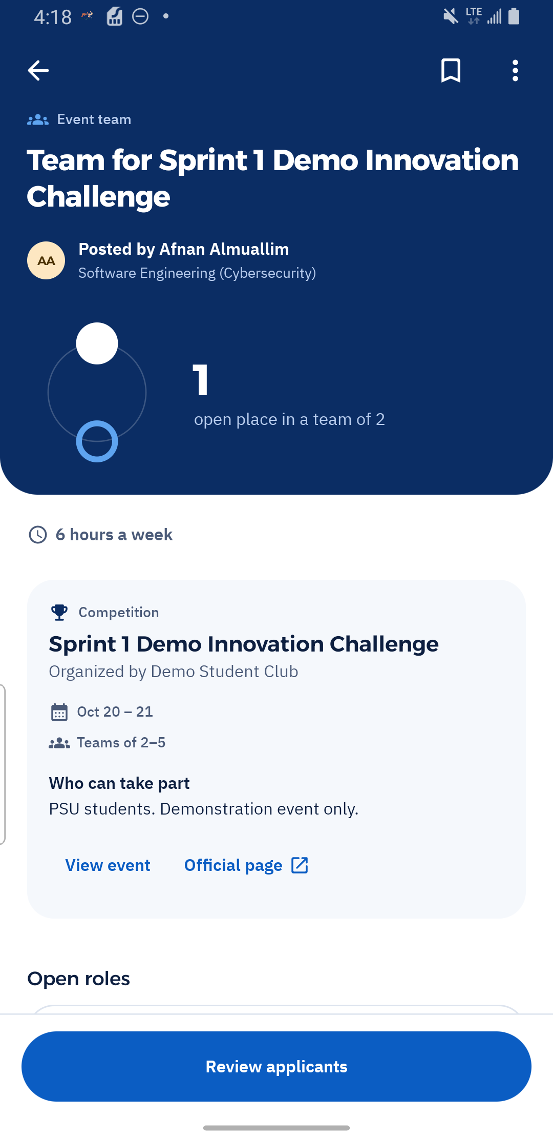  Figure 12. Published linked request retains the event reference, rules and vacancy.  US05/FR06 | Archive C31

UI screenshots Search results and empty state
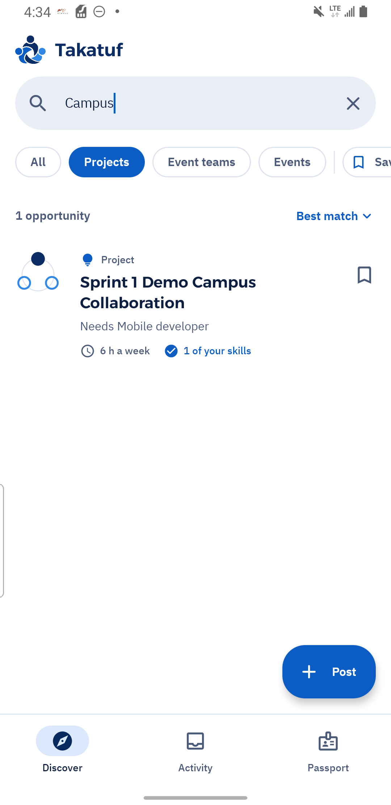  Figure 13. Searching Campus returns the project recruitment listing.  US06 / FR07 | Archive C40 | 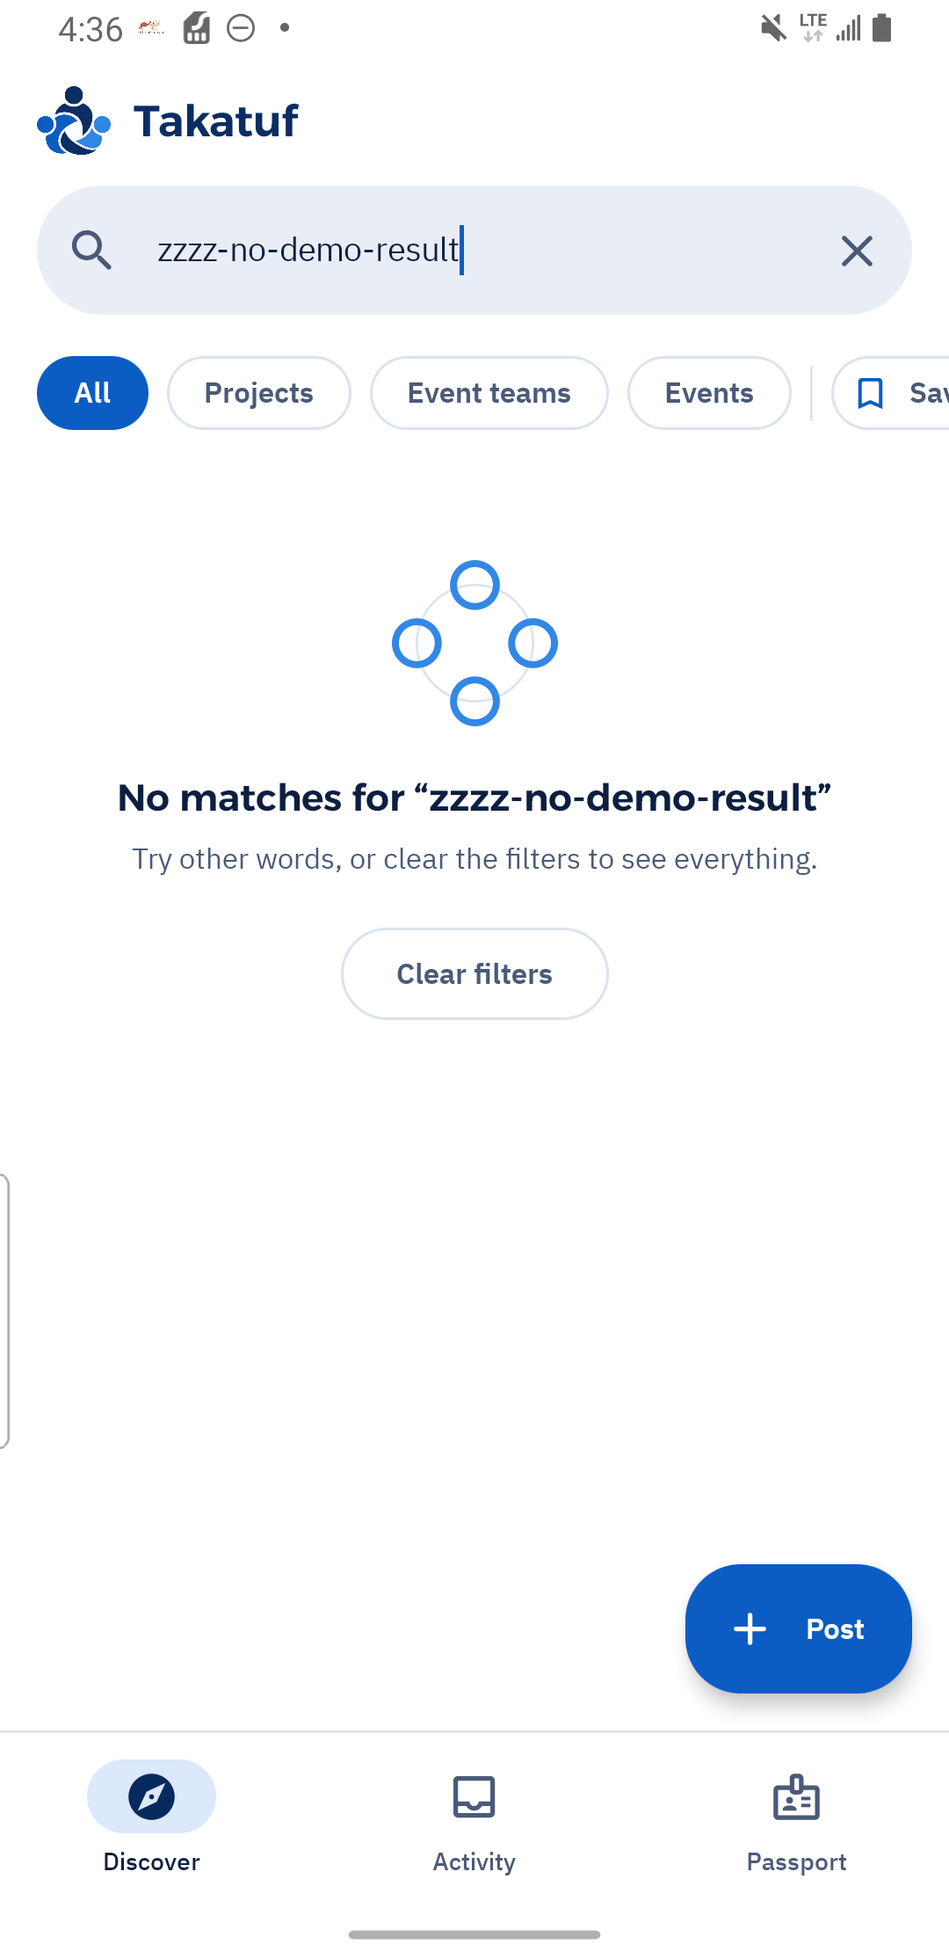  Figure 14. Unmatched search displays a clear no-results message.  US06 / FR07 | Archive C41

UI screenshots Filters and saved opportunities
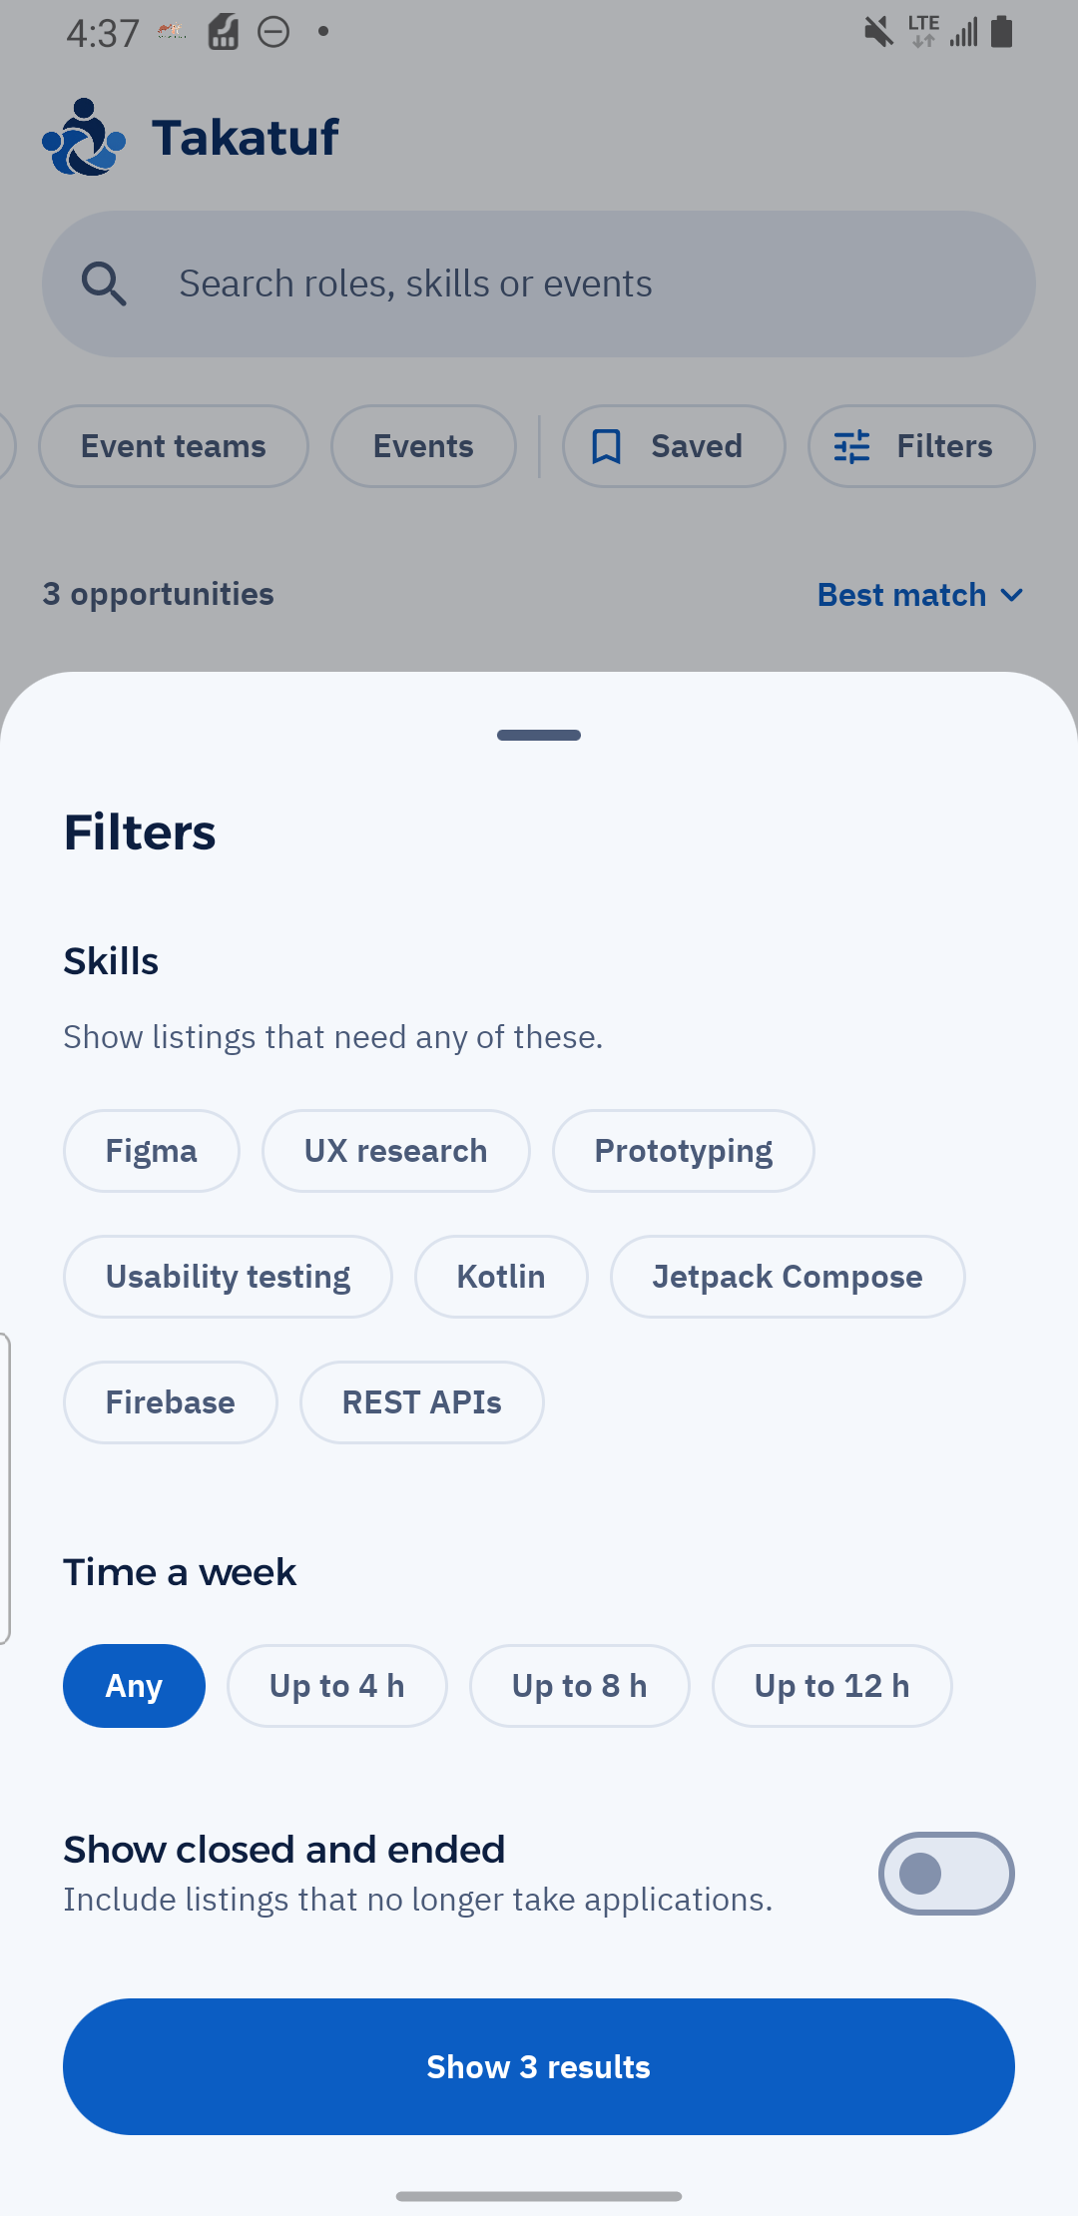  Figure 15. Discovery filters include skills, commitment and closed or ended listings.  US06 / FR07 | Archive C42 | 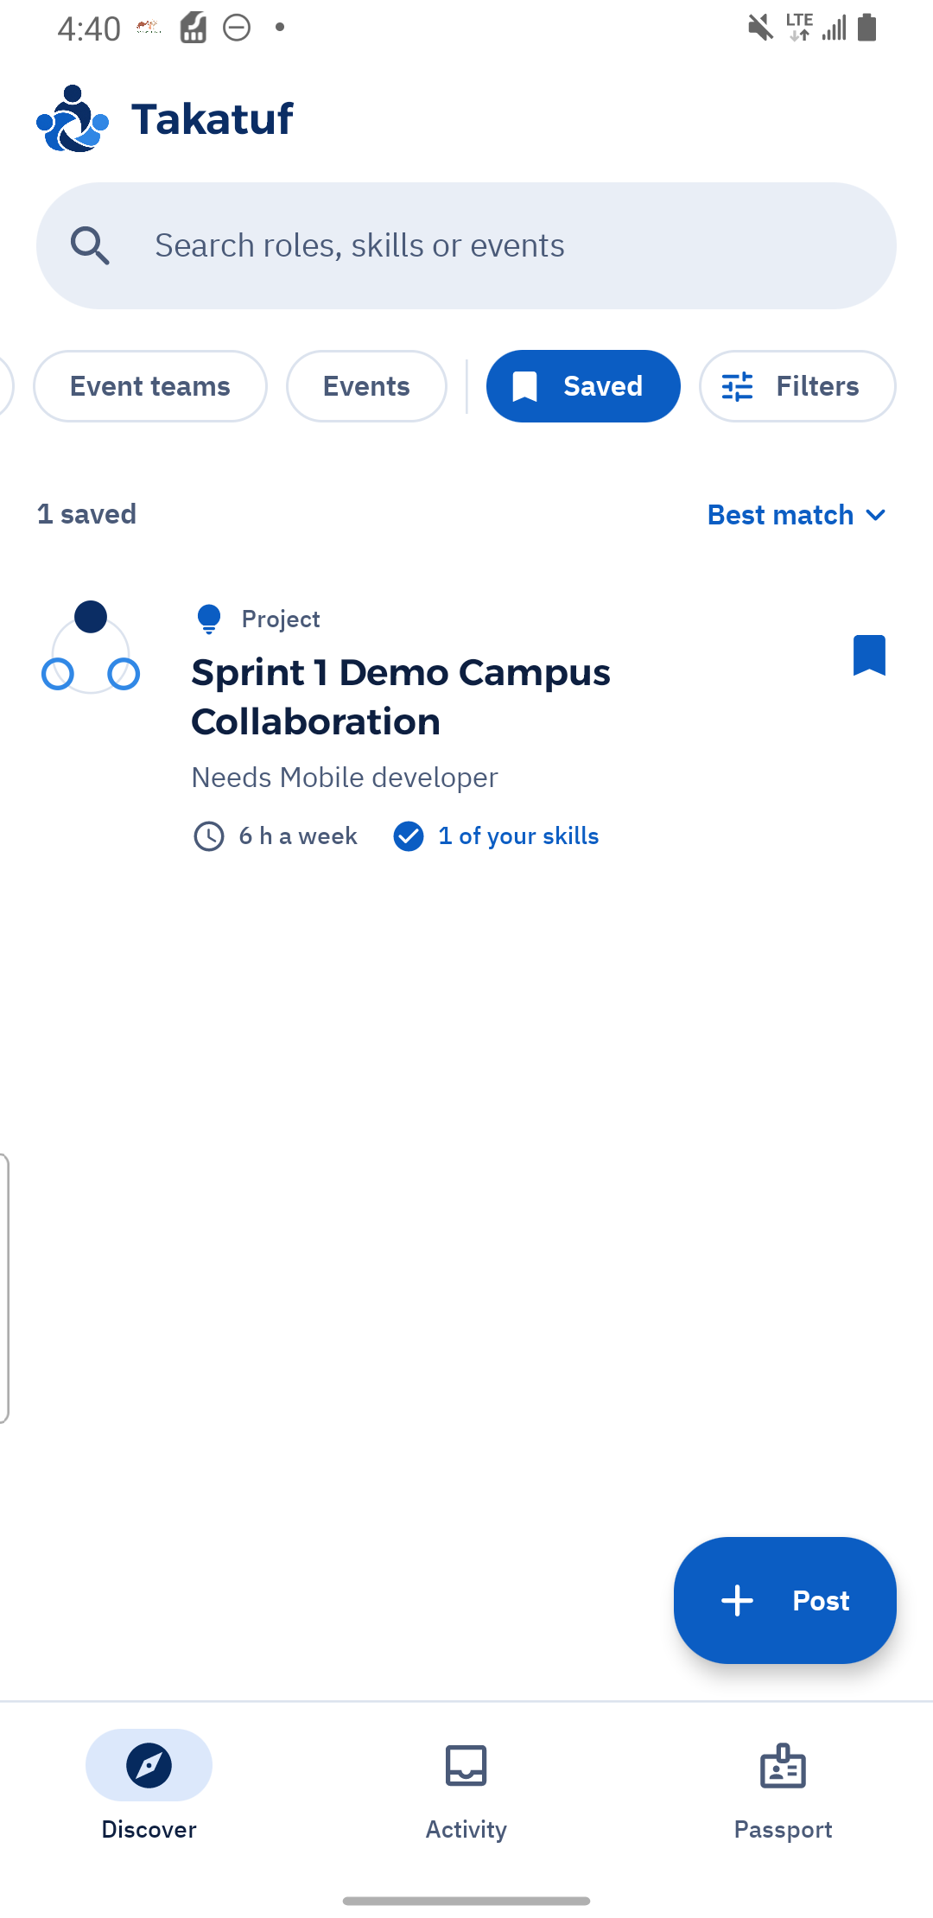  Figure 16. Saved opportunities retrieves the bookmarked project.  US06 / FR07 | Archive C45

UI screenshots Application validation and submission
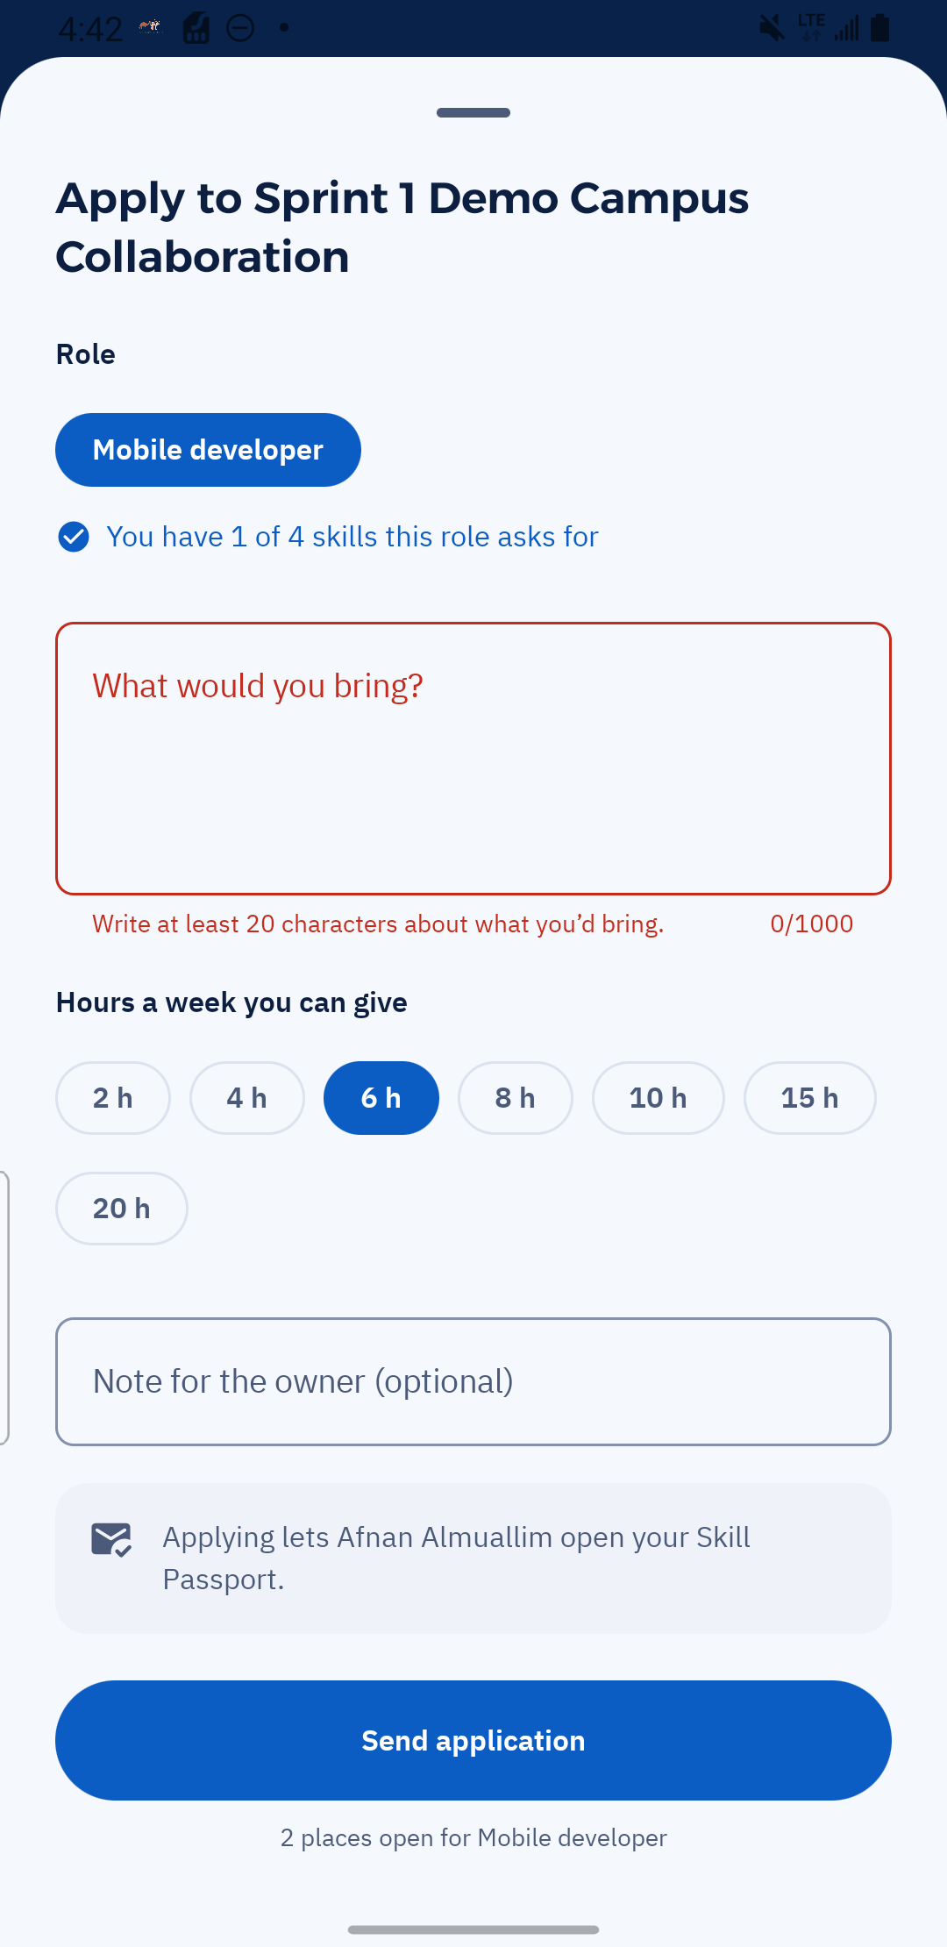  Figure 17. Blank application pitch is rejected with a 20-character minimum.  US07 / FR09 | Archive C50 | 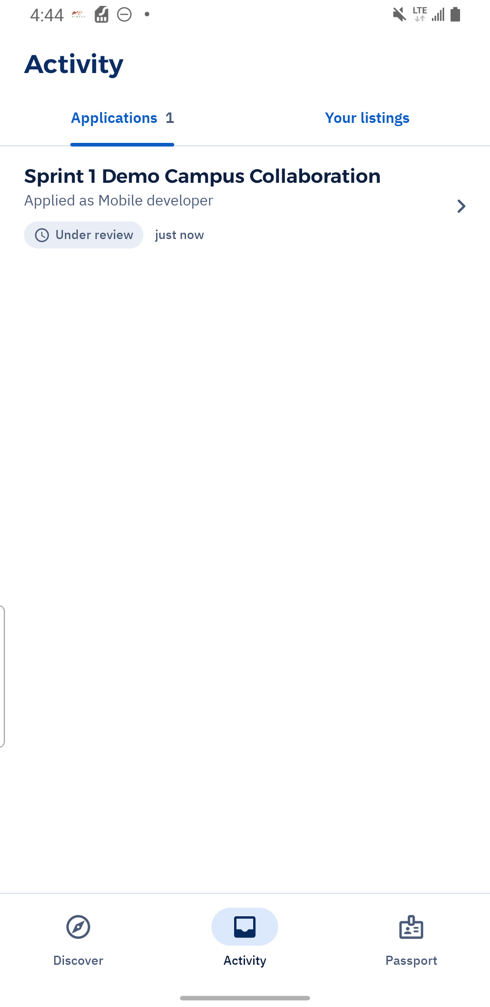  Figure 18. Successful application appears in Activity as Under review.  US07 / FR09 | Archive C53

UI screenshots Owner review and shortlisting
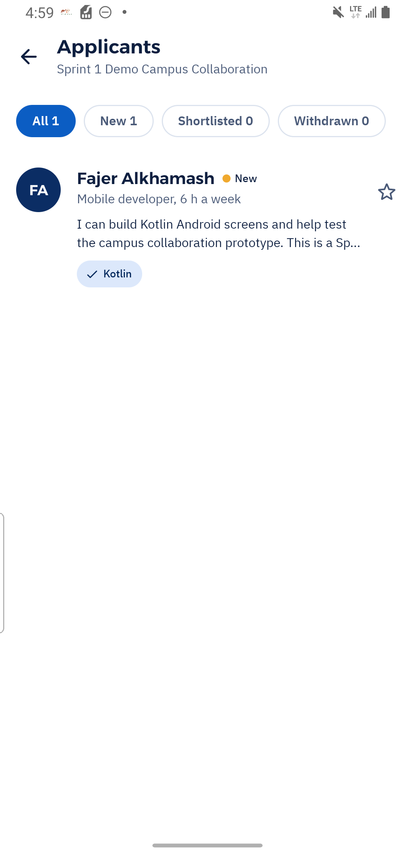  Figure 19. The owner reviews the populated applicant list.  US08 / FR10 | Archive C63 | 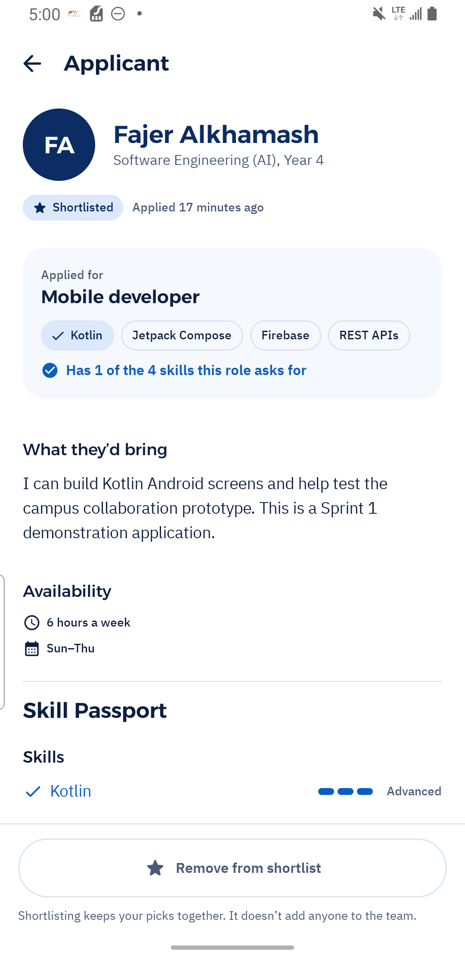  Figure 20. Shortlisting changes the application status to Shortlisted.  US08 / FR10 | Archive C65

UI screenshots Shortlist removal and student status
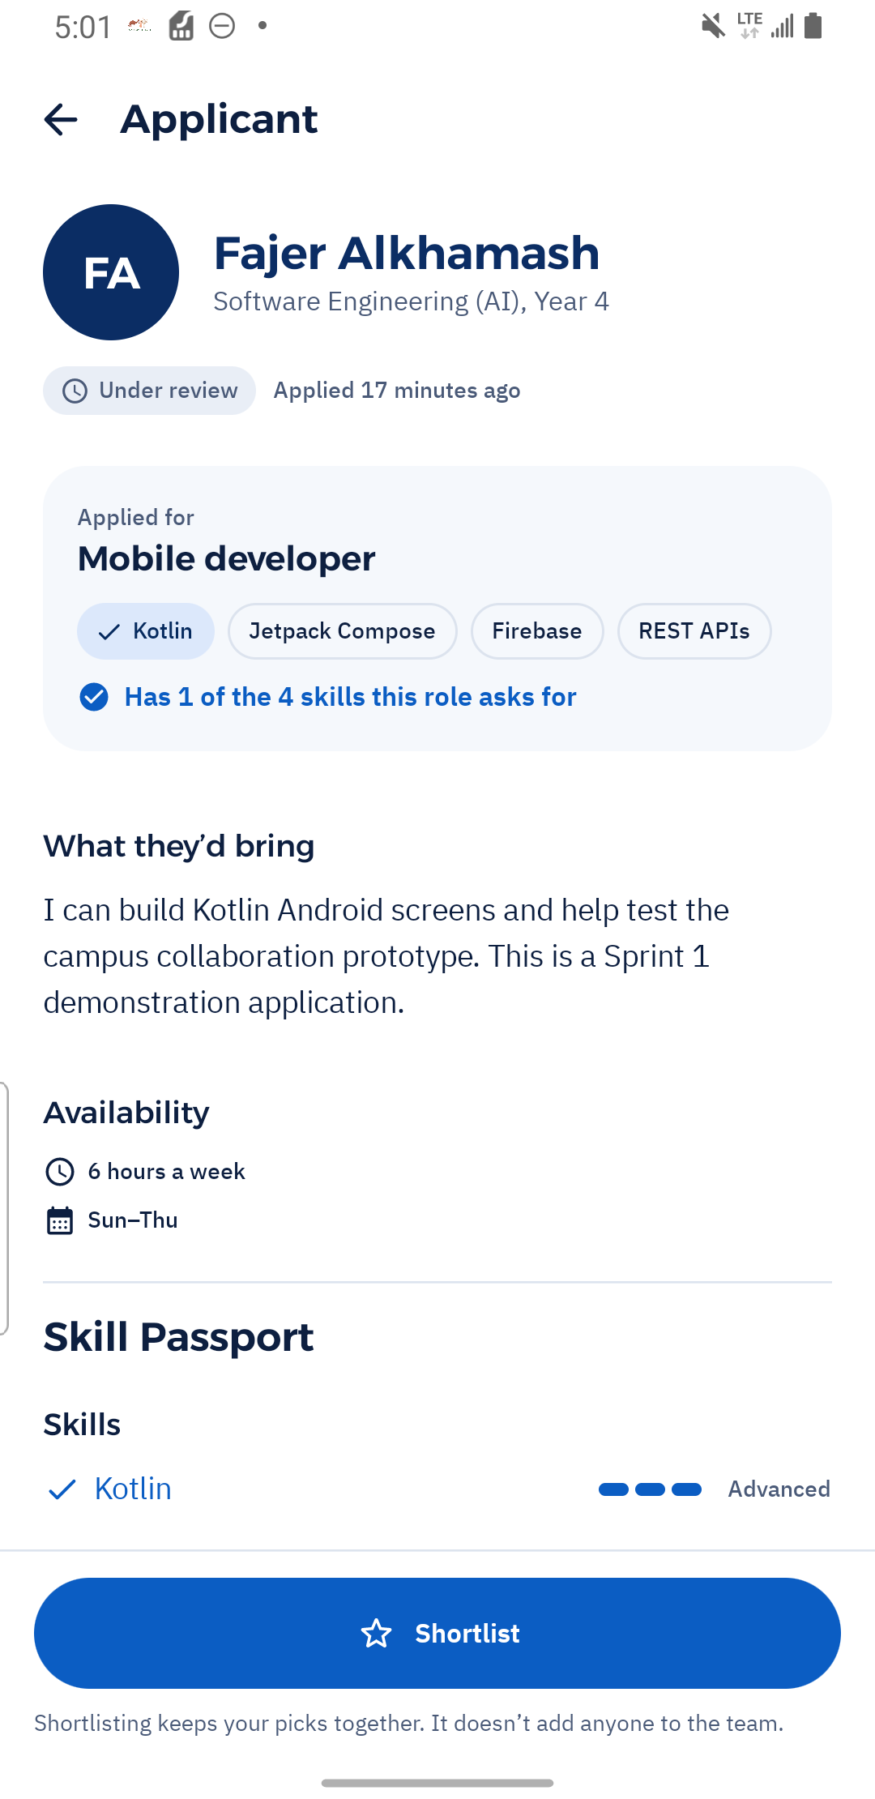  Figure 21. Removing from shortlist restores Under review.  US08 / FR10 | Archive C66 | 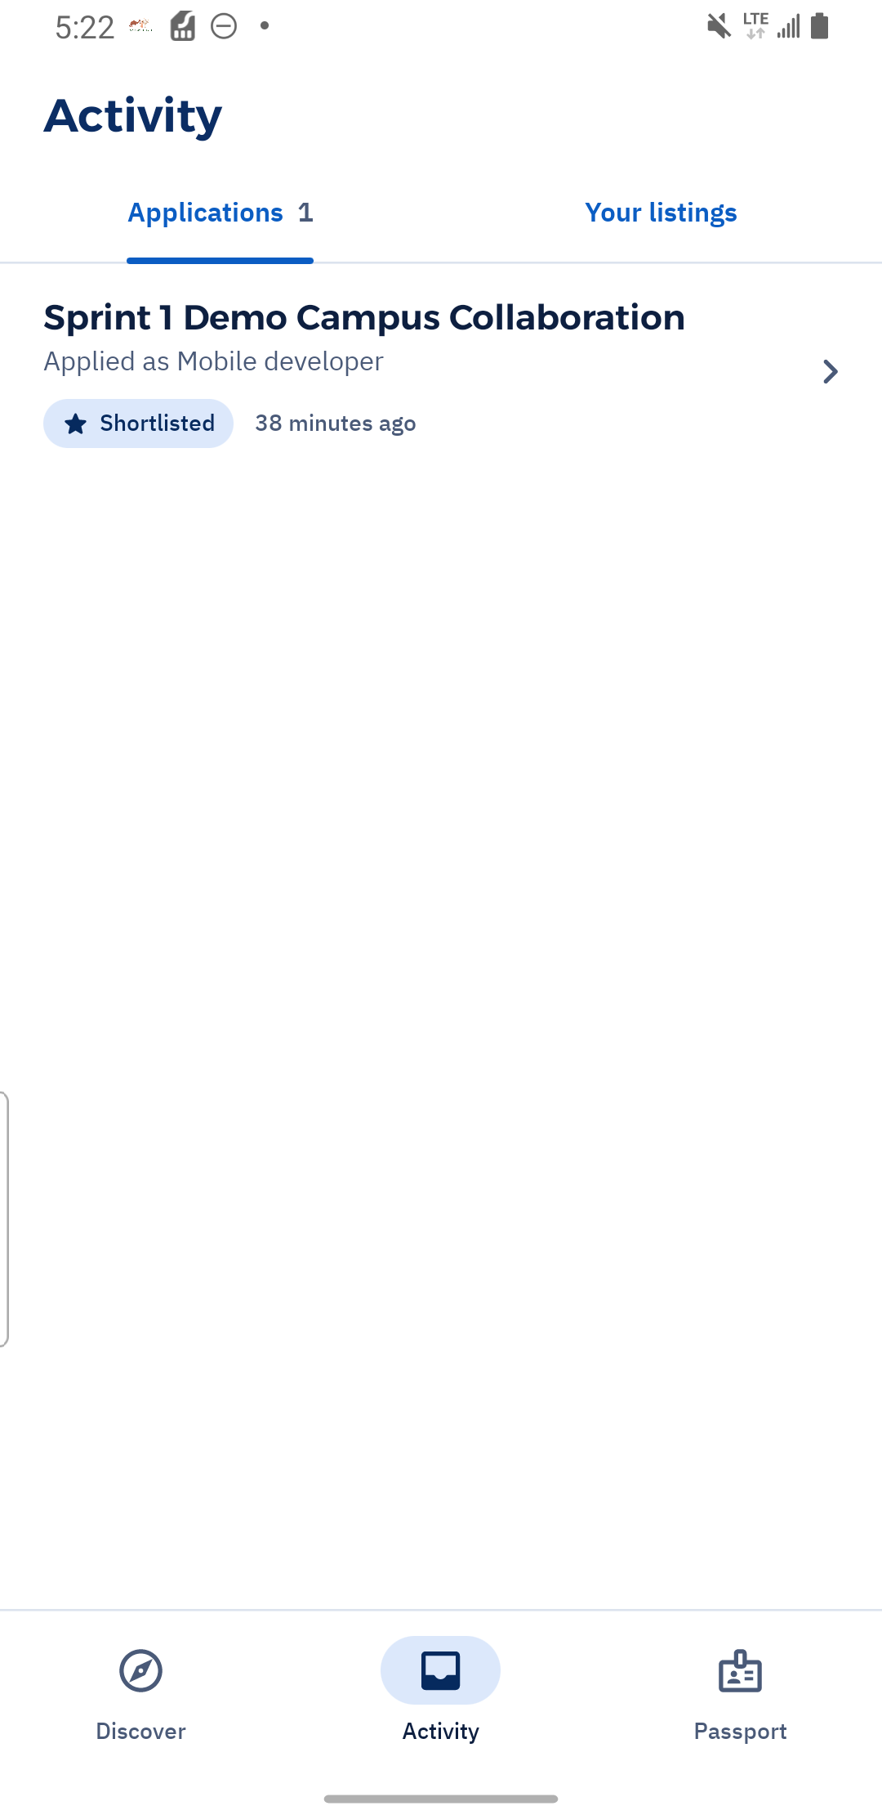  Figure 22. The student sees the owner's Shortlisted status after signing in.  US07, US08 / FR09, FR10 | Archive C74

UI screenshots Closed recruitment and withdrawal
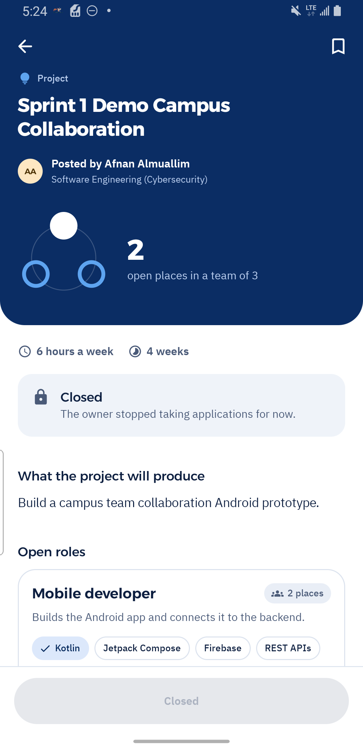  Figure 23. A closed project disables new application through the student UI.  US07 / FR09 | Archive C76 | 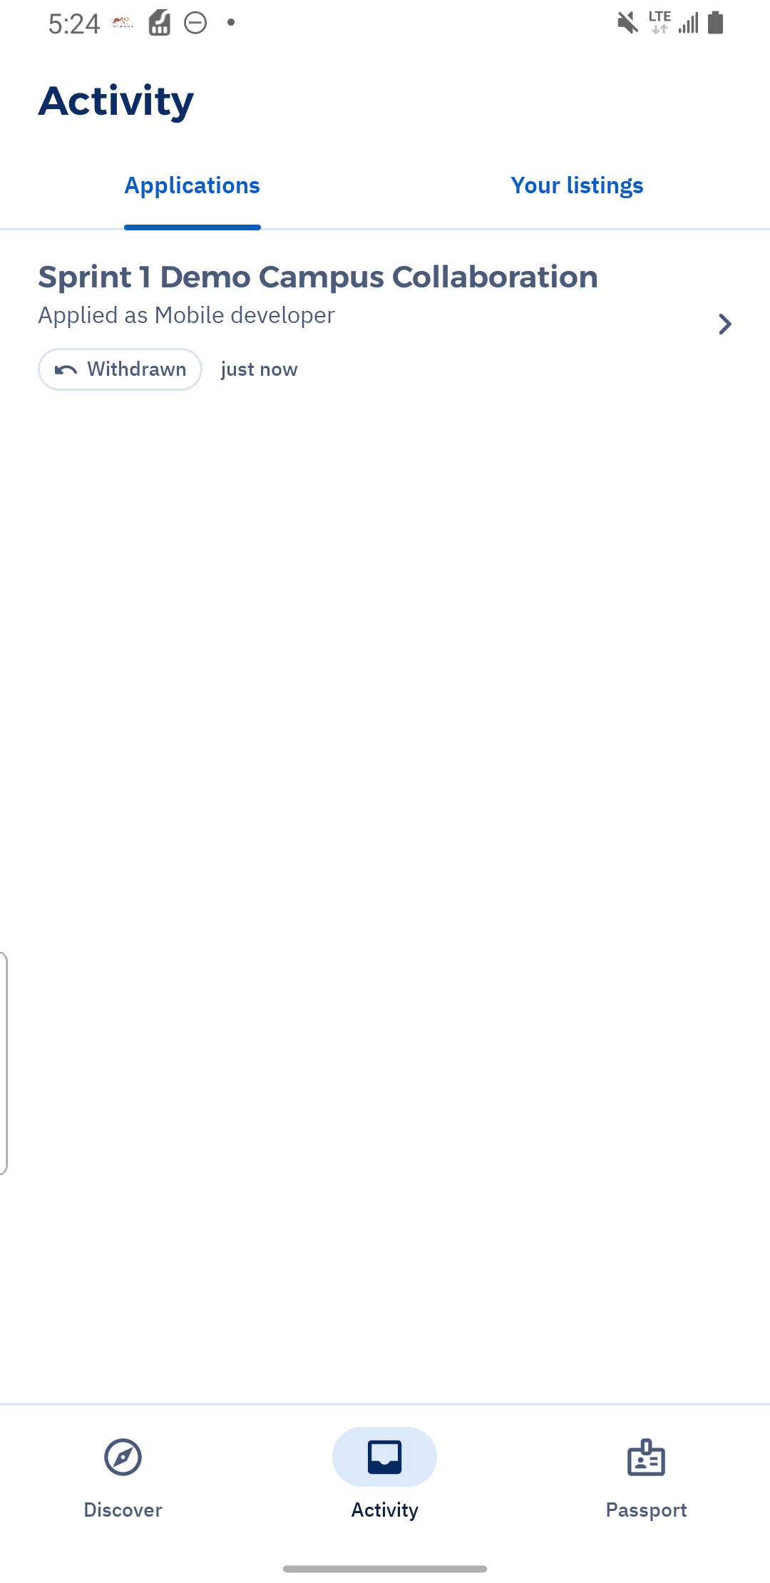  Figure 24. Withdrawal is recorded as Withdrawn in application history.  US07 / FR09 | Archive C77

UI screenshots Expired event and linked request inconsistency
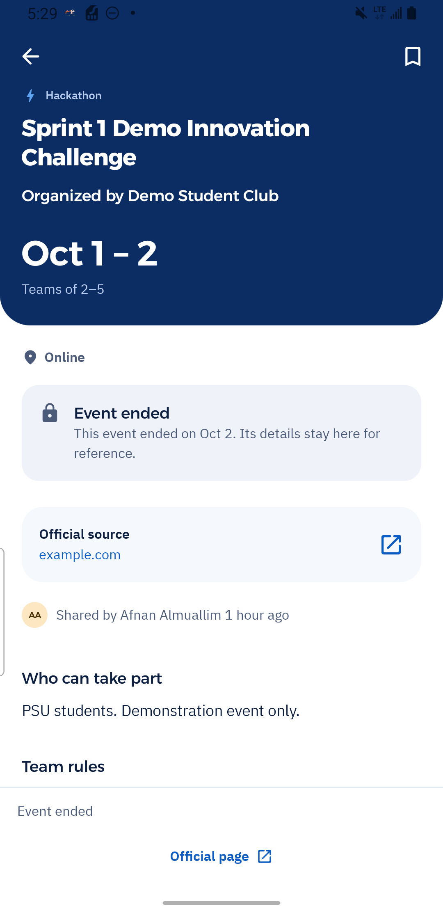  Figure 25. Parent event displays Event ended after dates are changed into the past.  US04, US05; FR05, FR06 | Archive C79 | 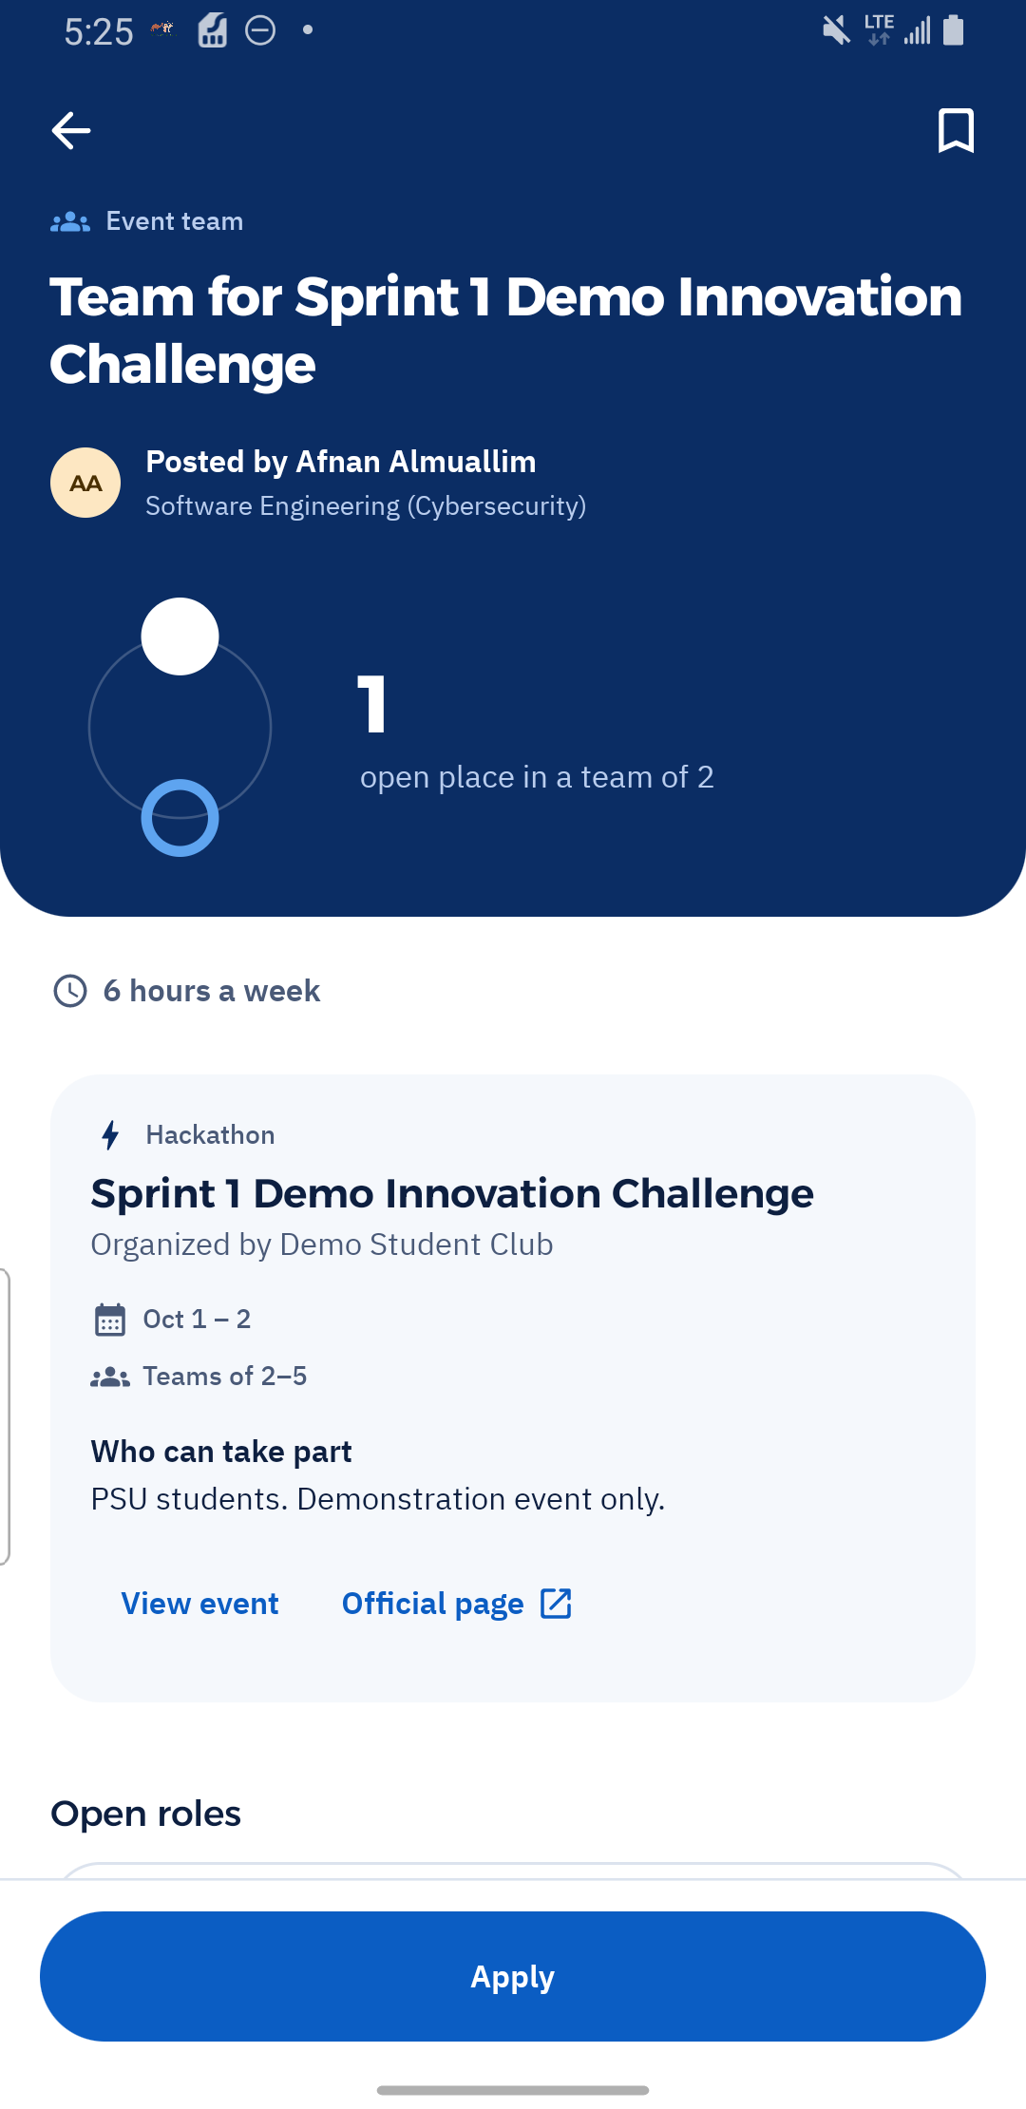  Figure 26. Linked request still shows Apply despite the ended parent; an expiry inconsistency.  US05, US07; FR06, FR09 | Archive C78

Requirements baseline
The planned foundation uses an Android app. The app uses Firebase Authentication and Cloud Firestore. .
User-facing matching belongs to Sprint 2. The existing SkillMatcher unit suite supplies three small synthetic checks of normalization, coverage and empty inputs. All passed in the initial unit run, but they do not validate role/availability scoring or a recommendation service. Best match UI labels are not counted toward Sprint 1 completion.
Story and requirement | Demonstrated scope | Verification limit
US01 / FR01 | Account creation, sign-in, sign-out and recovery form. | Reset completion and duplicate registration unverified.
US02 / FR02-FR03 | Passport onboarding/editing; unrelated and applicant-owner visibility views. | Only you enforcement and saved experience/link entry unverified.
US03 / FR04, FR08 | Project publication, validation, customized template and owner editor. | All field edits and direct owner authorization not fully tested.
US04 / FR05 | Competition/Hackathon publication and editing; ended-event label. | Exact end boundary fails unit check.
US05 / FR06 | Published event-linked request with roles, rules and source. | Apply stays enabled after parent dates change to the past.
US06 / FR07 | Search, filters, empty results, saved retrieval/removal. | Privacy of saved records through direct requests unverified.
US07 / FR09 | Application, status, withdrawal and closed-request UI. | Direct duplicate/closed submissions and concurrent requests unverified.
US08 / FR10 | Owner review, shortlist/remove and student-visible status. | Membership invariant and direct unrelated-user requests unverified.

Unit Test Cases
The selected table contains 16 executed JVM unit cases: 13 Pass and 3 Fail. Preconditions are isolated model fixtures and a fixed UTC instant where specified. Results come from the filtered JUnit run on 5 October, not from screenshots.
Case and criterion | Preconditions and execution | Expected and actual results | Status
U01 US01 / FR01  Minimum password length  AC: A valid password satisfies account validation. | JVM JUnit fixture; Call isStrongPassword with abcde123 (8 characters). | Expected: true  Actual: true; accepted.  Evidence: JUnit execution register. | Pass
U02 US01 / FR01  Below minimum password length  AC: Invalid account inputs receive validation. | JVM JUnit fixture; Call isStrongPassword with abcd123 (7 characters). | Expected: false  Actual: false; rejected.  Evidence: JUnit execution register. | Pass
U03 US01 / FR01  Required password character classes  AC: Invalid account inputs receive validation. | JVM JUnit fixture; Check letters only, digits only and empty input. | Expected: All return false.  Actual: All rejected.  Evidence: JUnit execution register. | Pass
U04 US02 / FR02  Normalize a web evidence link  AC: Optional work evidence can be added. | JVM JUnit fixture; Normalize a spaced github.com/afnan/project address. | Expected: https prefix added; spaces removed.  Actual: https://github.com/afnan/project.  Evidence: JUnit execution register. | Pass
U05 US02 / FR02  Reject non-web protocol  AC: Evidence input must be usable as a web link. | JVM JUnit fixture; Normalize ftp://example.org/file. | Expected: null; invalid protocol rejected.  Actual: null returned.  Evidence: JUnit execution register. | Pass
U06 US02 / FR02  Malformed or empty web links  AC: Invalid evidence input is rejected. | JVM JUnit fixture; Normalize not a link, https://localhost and empty text. | Expected: All return null.  Actual: All returned null.  Evidence: JUnit execution register. | Pass
U07 US02 / FR02  Empty and populated Passport  AC: A Passport represents saved capability evidence. | JVM JUnit fixture; Construct an empty Passport, then one with a portfolio link. | Expected: isEmpty true, then false.  Actual: Both assertions satisfied.  Evidence: JUnit execution register. | Pass
U08 US02 / FR02  Zero and positive availability boundary  AC: Availability can be recorded. | JVM JUnit fixture; Construct availability with 0 and 1 hours; add 1 hour to a Passport. | Expected: 0 unset; 1 set; Passport nonempty.  Actual: All assertions satisfied.  Evidence: JUnit execution register. | Pass
U09 US02 / FR02  Proficiency value conversion  AC: Skill proficiency can be represented. | JVM JUnit fixture; Convert stored levels 1, 2 and 3. | Expected: Beginner, Intermediate, Advanced.  Actual: Correct three levels returned.  Evidence: JUnit execution register. | Pass
U10 US03 / FR04, FR08  Vacancy aggregation  AC: Open positions are recorded for requested roles. | JVM JUnit fixture; Use two role fixtures with 2 and 1 openings. | Expected: openPlaces = 3.  Actual: 3 returned.  Evidence: JUnit execution register. | Pass
U11 US03 / FR04, FR08  Case-insensitive skill deduplication  AC: Requested role skills are represented consistently. | JVM JUnit fixture; Use Kotlin, Figma and figma in two roles. | Expected: Kotlin and Figma retained once.  Actual: Expected ordered list returned.  Evidence: JUnit execution register. | Pass
U12 US07 / FR09  Owner-closed listing  AC: Closed recruitment is unavailable for application. | JVM JUnit fixture; Evaluate a Closed project at a fixed instant. | Expected: ClosedByOwner.  Actual: ClosedByOwner returned.  Evidence: JUnit execution register. | Pass
U13 US07 / FR09  Exact deadline boundary  AC: Recruitment closes at its exclusive deadline. | JVM JUnit fixture; Fixed time 2026-10-05T00:00Z. Evaluate 1 ms before and at deadline. | Expected: Open before; DeadlinePassed at deadline.  Actual: Before open; at deadline null (open).  Evidence: JUnit execution register. | Fail
U14 US04 / FR05  Exact exclusive event end  AC: Expired events are identified. | JVM JUnit fixture; Evaluate an event 1 ms before and at its end instant. | Expected: Open before; Ended at end.  Actual: Before open; at end null (open).  Evidence: JUnit execution register. | Fail
U15 US05, US07 / FR06, FR09  Exact linked-event end  AC: A request linked to an ended event is closed. | JVM JUnit fixture; Evaluate a linked request 1 ms before and at event end. | Expected: Open before; EventOver at end.  Actual: Before open; at end null (open).  Evidence: JUnit execution register. | Fail
U16 US04 / FR05  Leap day and year-end conversion  AC: Event calendar dates remain consistent. | JVM JUnit fixture; Round-trip 2024-02-29; test end of 2026-12-31 and daysLeft. | Expected: Leap day preserved; end is 2027-01-01T00:00Z; 0 days left.  Actual: All date assertions satisfied.  Evidence: JUnit execution register. | Pass

Integration Test Cases
The following 11 selected cases use manual app interaction to examine connected UI and data flows. Nine passed their stated UI scope, one failed, and one is Blocked because its membership assertion remains unverified. Direct backend security, duplicate and concurrency tests were not executed.
Case and criterion | Preconditions and execution | Expected and actual results | Status
I01 US01 / FR01  Account access and retry  AC: Valid registration and sign-in work; invalid details produce feedback. | New test aliases. Register Afnan and Fajer; complete onboarding. Sign out; use Afnan's incorrect password, then correct credentials. | Expected: Accounts open onboarding; incorrect sign-in rejected; retry opens authenticated discovery.  Actual: Both accounts created; error shown; retry succeeded.  Evidence: captures C4, C6, C37, C60, C61. | Pass
I02 US02 / FR02  Passport save and update  AC: Skills, interests and availability can be saved and edited. | Fajer authenticated. Save onboarding; open editors; change Kotlin to Advanced and add Education; save and view Passport. | Expected: Updated skills and interests remain visible with saved availability.  Actual: Advanced Kotlin, Education and 6 hours/week displayed.  Evidence: captures C54, C55, C56, C58, C59. | Pass
I03 US02, US08 / FR03, FR10  Unrelated student and applicant owner access  AC: Selected visibility is enforced for another viewer. | Afnan selects Teams you apply to. Fajer opens Afnan's Passport. Fajer applies with the same visibility choice; Afnan reviews Fajer's Passport. | Expected: Unrelated view restricted; the request owner sees the applicant's shared Passport.  Actual: Afnan's content hidden from Fajer; Afnan saw Fajer's skill when reviewing.  Evidence: captures C13, C48, C64. | Pass
I04 US03 / FR04, FR08  Project form to published details and editor  AC: Outcome, roles, commitment and positions are captured; templates editable; required fields validated. | Afnan authenticated. Try empty publish; enter outcome; choose Mobile developer; change openings 1 to 2; choose 6 hours/4 weeks; publish; open Edit. | Expected: Empty fields rejected; published details retain values; owner editor loads them.  Actual: Validation shown; two vacancies and commitment retained; owner editor opened.  Evidence: captures C17, C18, C19, C20, C21, C24. | Pass
I05 US04 / FR05  Competition publish and Hackathon update  AC: Event records source, organizer, dates, eligibility and team rules; publisher remains distinct. | Afnan authenticated. Publish demo competition with required fields and 20-21 Oct dates; edit type to Hackathon; save and open details. | Expected: Required data retained; publisher separate from organizer; type update shown.  Actual: Competition published; same event saved as Hackathon with source and rules.  Evidence: captures C27, C29, C33, C34, C35. | Pass
I06 US05 / FR06, FR08  Event-linked request publication  AC: Request links to an event; roles, places, source and rules are visible. | Published demo event exists. Choose Find teammates; use UI/UX template with one place; publish; open details and owner editor. | Expected: Request retains actual event reference and recruitment details; relevant event rules visible.  Actual: Published linked request showed event card, official source, rules and one vacancy; editor loaded.  Evidence: captures C30, C31, C32, C71. | Pass
I07 US06 / FR07  Discovery and saved opportunities  AC: Search and filters return matches; empty results are clear; saved listings can be retrieved and removed. | Fajer authenticated; demo listings exist. Filter Projects; search Campus then unmatched text; apply Kotlin filter; save project; view Saved; remove it. | Expected: Correct match/empty states; saved item retrievable and removable.  Actual: Matching project, clear no-results state, skill-filter result and saved/removed states observed.  Evidence: captures C39, C40, C41, C43, C44, C45, C46. | Pass
I08 US07 / FR09  Application form and active-application UI  AC: Application records contribution and availability; duplicate active applications prevented. | Open project exists; Fajer has no application. Send blank pitch, then valid pitch with 6 hours/week. Reopen detail and Activity. | Expected: Blank pitch rejected; valid submission Under review; UI offers Withdraw instead of another Apply.  Actual: Minimum 20-character error; submission and Activity status shown; Apply absent. Direct duplicate requests untested.  Evidence: captures C49, C50, C51, C52, C53. | Pass
I09 US07 / FR09  Closed request and withdrawal UI  AC: Withdrawal changes status; closed requests do not accept new applications. | Fajer shortlisted. Afnan closes project; Fajer confirms withdrawal; view detail and Activity. | Expected: Withdrawn in history; Closed detail offers no new application action.  Actual: Withdrawn history and disabled Closed action observed. Direct backend attempts untested.  Evidence: captures C69, C70, C75, C76, C77. | Pass
I10 US08 / FR10  Shortlist status and membership invariant  AC: Owner can shortlist/remove candidates; membership must remain unchanged. | Fajer's application exists. Afnan reviews, shortlists, removes and shortlists again. Compare displayed vacancies and student status; inspect membership records. | Expected: Status tracks changes; no membership created; team capacity unchanged.  Actual: Status changes and student Shortlisted confirmed; UI counts unchanged. Membership records not inspected because Firebase testing is deferred.  Evidence: captures C63, C64, C65, C66, C67, C68, C74. | Blocked
I11 US04, US05, US07 / FR05, FR06, FR09  Parent event expiry propagated to linked request UI  AC: Expired events are identified; linked recruitment must not invite applications after expiry. | Existing linked request. Afnan changes parent dates to 1-2 Oct; Fajer opens parent and request, then taps Apply. | Expected: Parent marked ended; linked request closes or prevents entering application flow.  Actual: Parent Event ended; linked request shows revised dates but Apply remains enabled and form opens. No application sent.  Evidence: captures C72, C73, C78, C79, C80. | Fail

System Test Case
This system case records the complete manual owner-to-student journey on the connected Samsung phone. It passed the stated UI outcome. It does not certify backend authorization or membership integrity.
Case and criterion | Preconditions and execution | Expected and actual results | Status
S01 US03, US06, US07, US08 / FR04, FR07, FR09, FR10  Complete recruitment journey  AC: An owner publishes recruitment; another student discovers and applies; the owner reviews and shortlists. | Two dedicated accounts. Afnan publishes the Campus Collaboration project. Fajer discovers it and submits a contribution with 6 hours/week. Afnan signs in, opens applicants, reviews Fajer and shortlists. Fajer signs back in and checks Activity. | Expected: Project discoverable; application visible to owner; shortlist state visible to student.  Actual: All UI stages completed; Fajer's Activity displayed Shortlisted. This result covers the UI journey, not database membership or direct-request authorization.  Evidence: captures C21, C38, C51, C52, C63, C64, C65, C74. | Pass

9. Sprint Review
Planned: deliver US01-US08 and FR01-FR10, the Android/Python/relational foundation, initial recruitment journey and integration testing; investigate matching feasibility separately for Sprint 2.
Completed in the demonstrated UI scope: accounts, Passport onboarding and selected edits, project/event publication, event linking, role templates, discovery/saving, application/withdrawal and owner shortlist status. The complete owner-publish/student-apply/owner-shortlist journey was observed.
Partially completed or unresolved: exact expiry boundaries fail, and an event-linked request remains actionable after its parent date update. Recovery completion, some profile fields and membership invariants remain unverified. Backend/API/relational verification and rules execution are incomplete or deferred; their status cannot establish whether the planned services are implemented. Existing skill checks provide limited feasibility evidence, not full matching evaluation.

